

**YOGA CENTER**

**Software Design Specification**

– HoChiMinh, July 2023 –

**Record of changeS**

| **Date** | **A* M, D** | **In charge** | **Change Description** |
| --- | --- | --- | --- |
| July 12 | A | AnLH | Add detail Code Designs 3, 4, 5 |
| July 12 | A | DungVNT | Code package added, |
| July 15 | A | ThangNC | Code package modified and add description |
| July 15 | A | ThangNC | Add details to section II Code Designs item number 8, 9, 10 |
| July 14 | A | LongNT | Modified details to section II Code Designs - Sequence diagram of item 6, 7 |
| July 15 | M | AnLH | Add Code Designs (11, 12, 13, 14) |
| July 15 | M | DatTGT | Modified table description (13, 18, 19, 20) |
| July 17 | A | ThangNC | Add Search, Category. HomePage function |
| July 17 | A | DatTGT | Double check & edit errors |
| July 18 | A | DungVNT | Add details to section II Code Designs item number 1, 6, 9, 15 |
| July 19 | A | AnLH | Add description of table in database design |
| July 20 | A | LongNT, DungVNT | Check All |

*A - Added M - Modified D - Deleted

**Table of Contents**

I. Overview 5

1. Code Packages 5

2. Database Design 6

a. Database Schema 6

b. Table Description 6

3. Usecase 7

4. ERD Diagram 8

II. Code Designs 9

1. Payment course 9

a. Class Diagram 9

b. Class Specifications 9

c. Sequence Diagram(s) 11

d. Database Queries 11

2. View Blog 12

a. Class Diagram 12

b. Class Specifications 12

c. Sequence Diagram(s) 14

d. Database Queries 14

3. Manage Account 15

a. Class Diagram 15

b. Class Specifications 15

c. Sequence Diagram(s) 17

d. Database Queries 17

4. View Timetable 18

a. Class Diagram 18

b. Class Specifications 18

c. Sequence Diagram(s) 19

5. Booking course 21

a. Class Diagram 21

b. Class Specifications 21

AccountRepository Class 21

c. Sequence Diagram(s) 24

d. Database Queries 24

6. Bill Analysis 26

a. Class Diagram 26

b. Class Specifications 26

c. Sequence Diagram(s) 28

d. Database Queries 28

7. Rating course 29

a. Class Diagram 29

b. Class Specifications 29

AccountRepository Class 30

c. Sequence Diagram(s) 32

d. Database Queries 32

8. Cashier ViewBill 33

a. Class Diagram 33

b. Class Specifications 33

c. Sequence Diagram(s) 35

d. Database Queries 35

9. Blog Analysis 36

a. Class Diagram 36

b. Class Specifications 36

c. Sequence Diagram(s) 38

d. Database Queries 38

10. Cashier UpdateBill 39

a. Class Diagram 39

b. Class Specifications 39

c. Sequence Diagram(s) 41

d. Database Queries 41

11. Update User Profile 42

a. Class Diagram 42

b. Class Specifications 42

AccountRepository Class 42

c. Sequence Diagram(s) 43

d. Database Queries 43

12. View Timetable List 44

a. Class Diagram 44

b. Class Specifications 44

c. Sequence Diagram(s) 45

d. Database Queries 45

13. Buy membership 46

a. Class Diagram 46

b. Class Specifications 46

c. Sequence Diagram(s) 48

d. Database Queries 48

14. View membership 49

a. Class Diagram 49

b. Class Specifications 50

c. Sequence Diagram(s) 52

d. Database Queries 52

15. View Bill 53

a. Class Diagram 53

b. Class Specifications 54

c. Sequence Diagram(s) 54

d. Database Queries 55

16. View Course Time List 55

a. Class Diagram 55

b. Class Specifications 56

c. Sequence Diagram(s) 57

d. Database Queries 57

17. Cancel Booking 58

a. Class Diagram 58

b. Class Specifications 58

AccountRepository Class 58

BillRepository Class 59

c. Sequence Diagram(s) 60

d. Database Queries 60

18. Cashier ViewBillMembership 61

a. Class Diagram 61

b. Class Specifications 61

c. Sequence Diagram(s) 62

d. Database Queries 62

# I. Overview

## 1. Code Packages

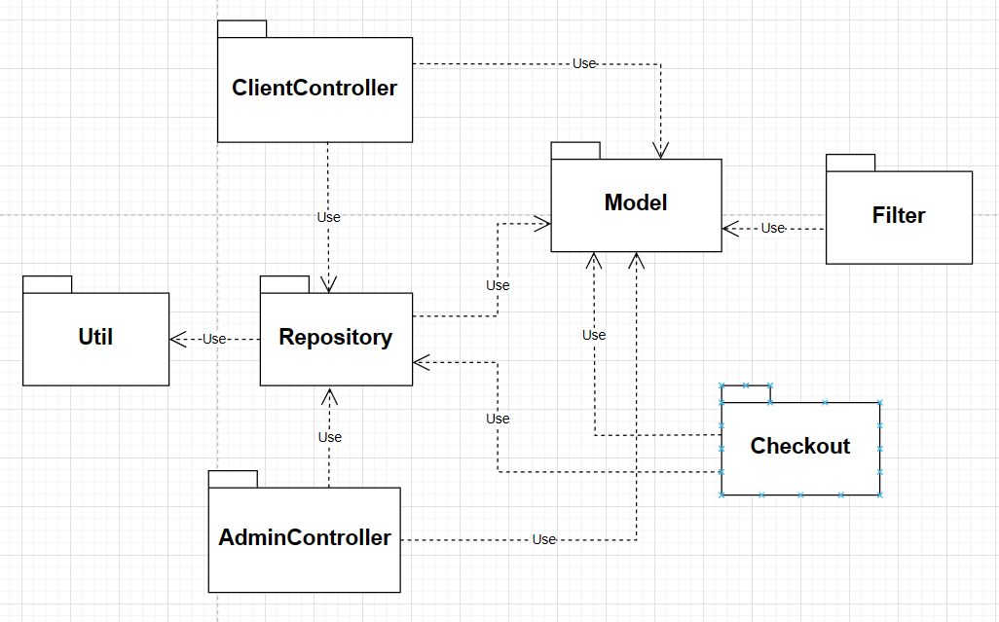

***Package descriptions***

| **No** | **Package** | **Description** |
| --- | --- | --- |
| 01 | Util | Contains various utility classes and components that provide generic functionalities and services that can be used throughout the application. |
| 02 | Repository | Provides an interface for accessing and manipulating data from the underlying data source. |
| 03 | Model | Defines the domain models that represent the entities in the application. |
| 04 | ClientController | Handles client interactions and invokes appropriate actions. |
| 05 | AdminController | Handles admin interactions and invokes appropriate actions. |
| 06 | Checkout | Handles client interactions in checkout progress and interacts with a payment gateway to generate bills and checkout. |
| 07 | Filter | Restrict users to interact directly with the website via URL. Handle authentication user. |

## 2. Database Design

### a. Database Schema

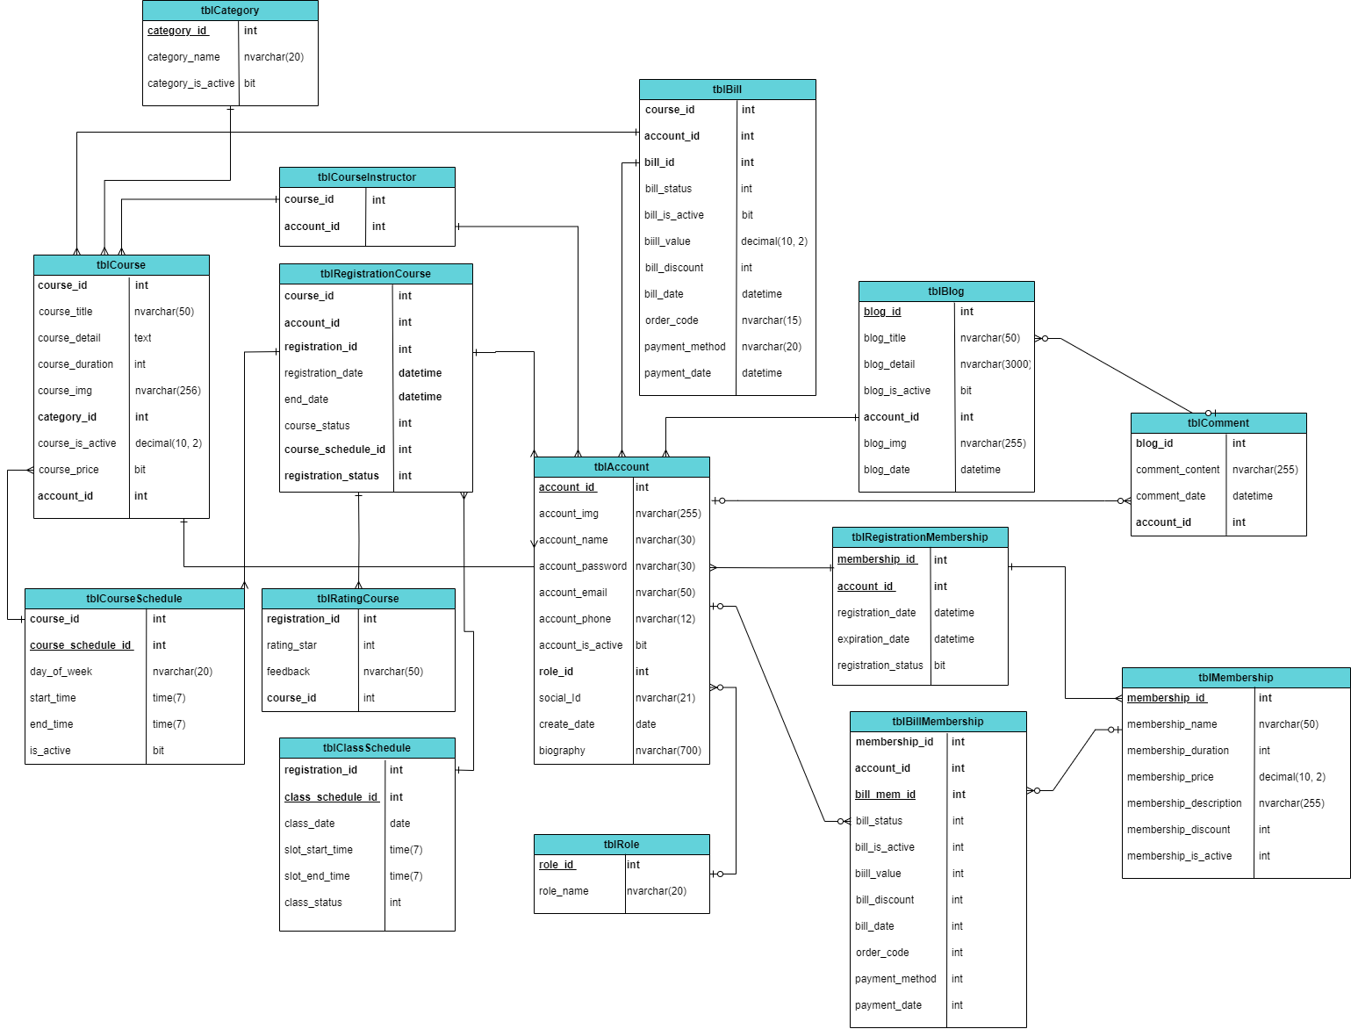

### b. Table Description

| **No** | **Table** | **Description** |
| --- | --- | --- |
| 01 | tblCategory | tblCategory is related to category_id, category_name, and category_is_active. Categories are used to represent the type of yoga of the course. |
| 02 | tblCourse | tblCourse will include information such as name, time, type, price, participants, status, and an image representing the course. The course will allow users to buy and participate. |
| 03 | tblCourseSchedule | Course Schedule - specific attributes include the date of the week, slot start time, slot end time, and is active. |
| 04 | tblCourseInstructor | tblCourseInstructor is composed of account_id and course_id. This table will determine which account will be the trainer of which course. |
| 05 | tblRegistrationCourse | tblRegistrationCourse will include course_id, account_id, registration_id, registration_date , end_date, course_status , course_schedule_id , registration_status. This table will store the account's course registration information. |
| 06 | tblClassSchedule | Class Schedule - specific attributes include class date, slot start time, slot end time, and status. |
| 07 | tblRatingCourse | Store data with feedback, rating star, and course ID which course users register |
| 08 | tblComment | It is a comment from the user it is a possible vision all viewer |
| 09 | tblMembership | Set of "Membership" in the system which provides a lot of discount for the trainee, and benefits at the center when becoming a member. |
| 10 | tblBill | Store information user who has paid for Course with attributes including the Account ID, Course ID, Bill ID, Status, Price, Discount, Payment Date, Payment Method and Order Code |
| 11 | tblBlog | Blog - specific attributes include blog detail, title, create date,e.g |
| 12 | tblRegistrationMemembership | tblRegistrationMemembership will include membership_id, account_id, registration_date, expiration_date, registration_status. This table will store the membership card information of the account when the account registers to buy or update. |
| 13 | tblBillMembership | Store information user who has paid for membership with attributes including Account ID, Membership ID, Bill Membership ID, Status, Price, Discount, Payment Date, and Order Code. |
| 14 | tblRole | Role-related information such as role ID and role name. Roles are used to group users with similar permissions or access levels. |
| 15 | tblAccount | Account-specific information such as account ID, username, email, password, and other user-related properties. |

## 

## 

## 

## 3. Usecase

# 

## 

## 

## 4. ERD Diagram

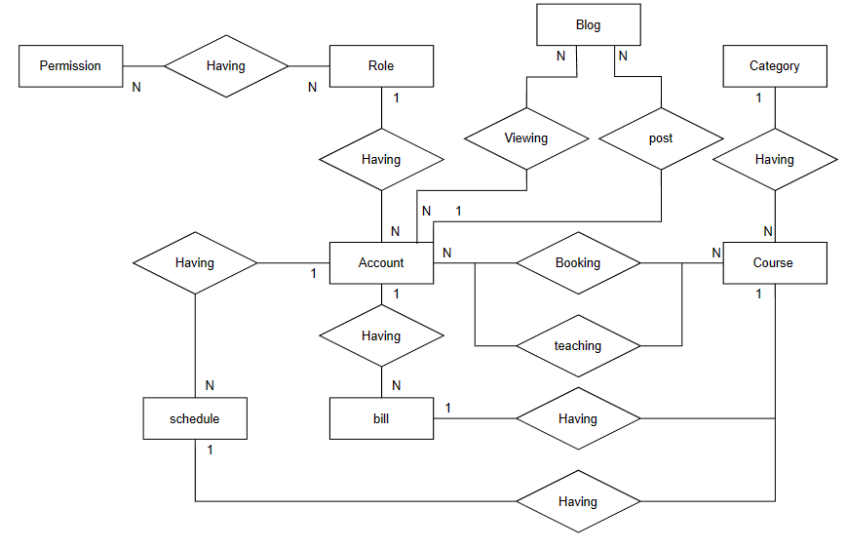

# II. Code Designs

## 1. Payment course

### a. Class Diagram

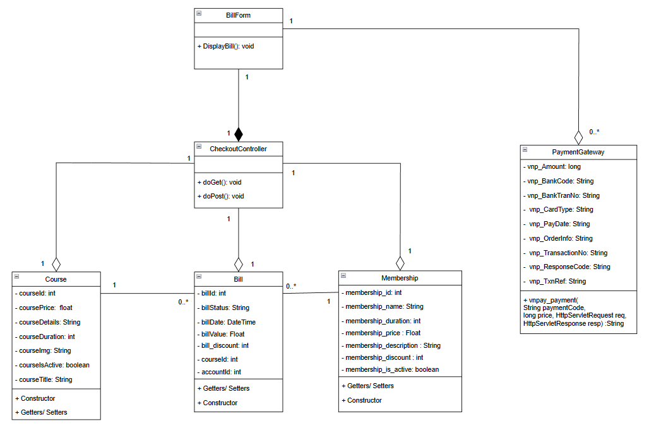

### b. Class Specifications

#### Course Class

| **No** | **Method** | **Description** |
| --- | --- | --- |
| 01 | Getter | Get value in attributes |
| 02 | Setter | Set value for attributes |
| 03 | Constructor | Generate Course object |

#### Bill Class

| **No** | **Method** | **Description** |
| --- | --- | --- |
| 01 | Getter | Get value in attributes |
| 02 | Setter | Set value for attributes |
| 03 | Constructor | Generate Bill object |

#### Membership Class

| **No** | **Method** | **Description** |
| --- | --- | --- |
| 01 | Getter | Get value in attributes |
| 02 | Setter | Set value for attributes |
| 03 | Constructor | Generate Membership object |

#### CheckoutController Class

| **No** | **Method** | **Description** |
| --- | --- | --- |
| 01 | doget() | Input payment method, generate and get oder code back and store to database |
| 02 | doPost() | Input payment method, generate and get oder code back and store to database |

#### BillForm Class

| **No** | **Method** | **Description** |
| --- | --- | --- |
| 01 | DisplayBill() | Use jsp, jstl, css to generate view for checkout |

#### PaymentGateway Class

| **No** | **Method** | **Description** |
| --- | --- | --- |
| 01 | vnpay_payment(..) | Send information of the bill to payment gateway and get back attribute to store in database |

### c. Sequence Diagram(s)

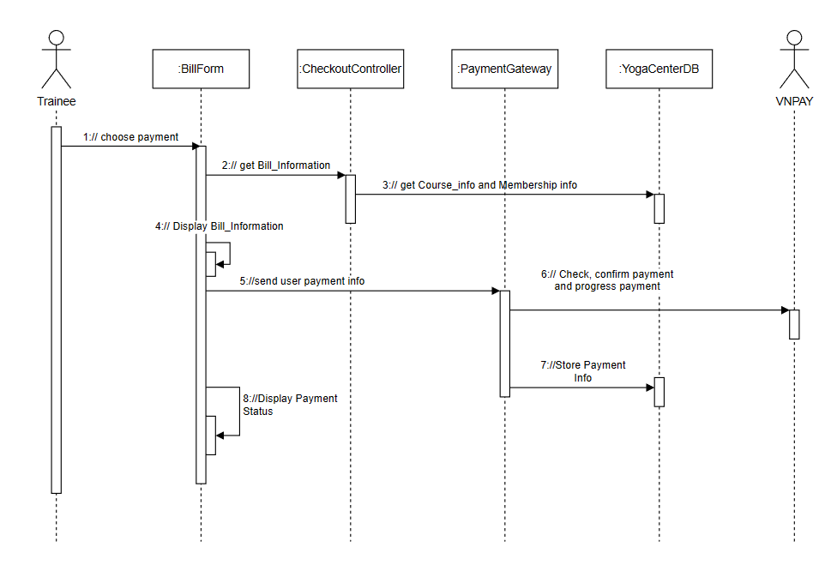

### d. Database Queries

SELECT * FROM TblBill where id =?

SELECT * FROM TblCourse where id =?

SELECT * FROM TblMemberShip where id =?

INSERT INTO tblBill (course_id, account_id, bill_status, bill_is_active, bill_value, bill_discount, bill_date, order_code, payment_method) VALUES (?, ?, ?, ?, ?, ?, ?, ?, ?)

## 2. View Blog

### a. Class Diagram

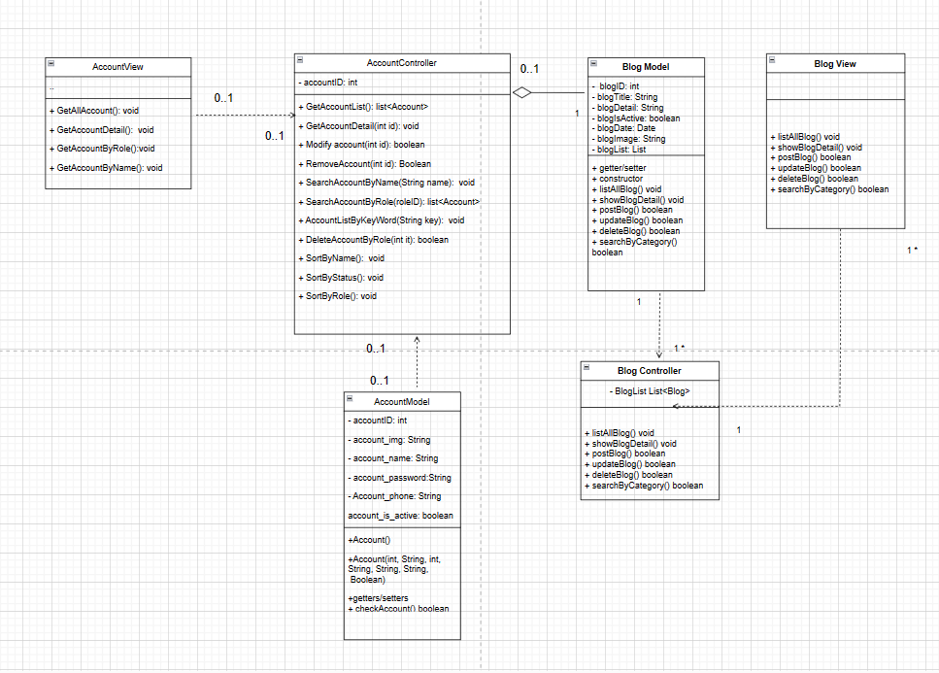

### b. Class Specifications

#### BlogModel Class

| **No** | **Method** | **Description** |
| --- | --- | --- |
| 01 | Blog() | The constructor for class |
| 02 | setter() | Method to update attribute for class, input is the data type of attribute, the output is void |
| 03 | getter() | Method to get the value of an attribute in class, out is value off attribute, input is none |

#### BlogRepository Class

| **No** | **Method** | **Description** |
| --- | --- | --- |
| 01 | List<Blog> getAll | Method get all blog from database |
| 02 | Blog detail(int id) | Method get detail blog where blog_id =? |
| 03 | update(Blog c) | Method update blog_title , blog_detail, blog_is_active, account_id, blog_img, blog_date where blog_id = ? |
| 04 | delete(int id) | Method update blog_is_active where blog_id = ? |
| 05 | count() | Get number of blog |
| 06 | create(Blog blog) | Add new blog |
| 07 | getRecentBlog(int offset,int next,int accountId) | Get all blog where account_id = ? |
| 08 | getTotalBlog(int accountId) | Get count of blog where account_id = ? |

#### 

#### BlogHomeController Class

| **No** | **Method** | **Description** |
| --- | --- | --- |
| 01 | doGet() | Method get all blog recent and blog pagination for blog |
| 02 | doPost() | Get data from user when post blog, edit the blog and delete blog |
|  |  |  |
|  |  |  |

#### 

### c. Sequence Diagram(s)

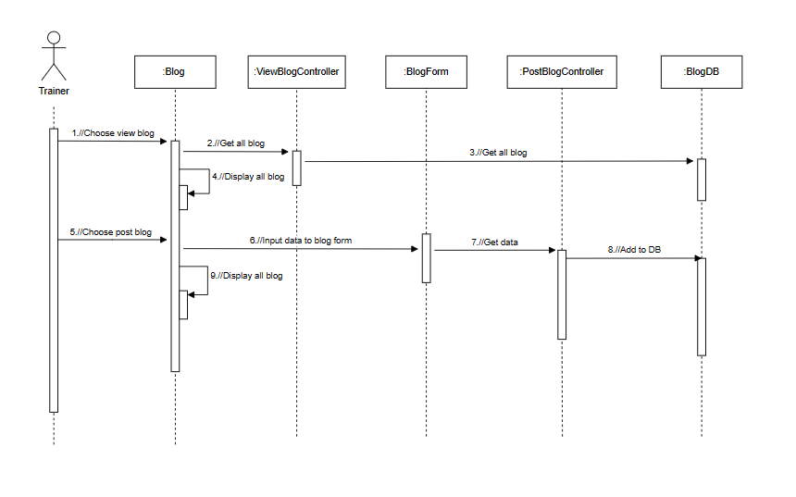

### d. Database Queries

select * from tblBlog order by blog_date desc OFFSET? ROWS FETCH NEXT? ROWS ONLY

select count(*) as num from tblBlog

INSERT INTO tblBlog ("

+ "blog_img, blog_date, account_id, "

+ "blog_detail, blog_title) "

+ "VALUES (?, ?, ?, ?, ?)"

select * from tblBlog where account_id=? order by blog_date DESC OFFSET? ROWS FETCH NEXT? ROWS ONLY

select COUNT(*) as count from tblBlog where account_id=?

select * from tblBlog where blog_id =?

update tblBlog set blog_title=? , blog_detail=? , account_id=? , blog_date=? , blog_img=? where blog_id=?

delete from tblBlog where blog_id=?

## 3. Manage Account

### a. Class Diagram

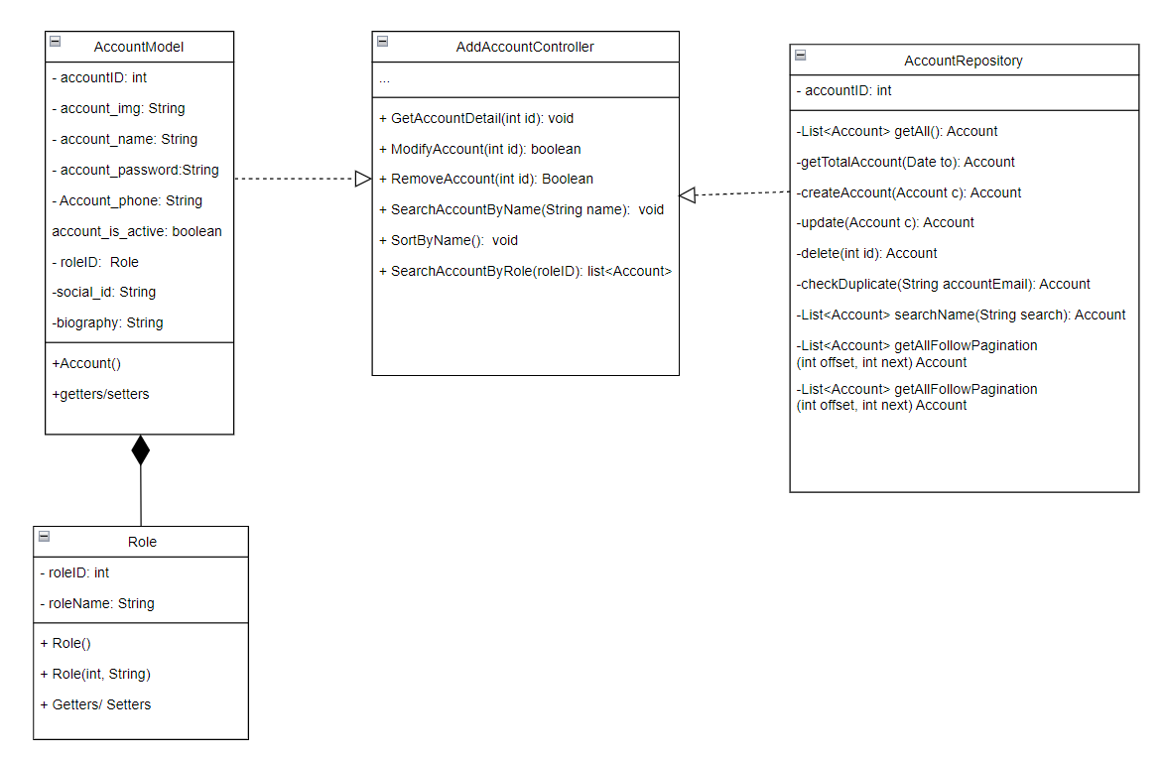

### b. Class Specifications

Description: Display the account information that has joined the system and performed the functions on the account.

#### AccountModel Class

| **No** | **Method** | **Description** |
| --- | --- | --- |
| 01 | Account() | Constructor for class. |
| 02 | setter() | Method to set the date in class. |
| 03 | getter() | Method to get the date from class. |

***Account Repository***

| **No** | **Method** | **Description** |
| --- | --- | --- |
| 01 | List<Account> getAll() | The function used to query data, get an account list from the database |
| 02 | getTotalAccount() | The function used to query data, get an account list by date nearest to the database |
| 03 | updateAccount() | The function used to query data, edit data of account into the database |
| 04 | createAccount() | The function used to query data, insert new account into the database |
| 06 | deleteAccount() | The function used to query data, update status of the account into the database |
| 07 | checkDuplicate() | The function check duplicate email when creating a new account |
| 08 | List<Account> searchName | The function used to query data,get account through keywords from the database |
| 09 | List<Account> getAllowPagination | The function used to pagination AccountPage |

AccountController

| **No** | **Method** | **Description** |
| --- | --- | --- |
| 01 | doGet() GetAccountDetail | The function displays all account details |
| 02 | doGet() ModifyAccountl | Function used to display user detail so that that can be edited |
| 03 | doGet() RemoveAccount | Function used to ban an account |
| 04 | doGet() SearchAccountByName | Function used to find an account by their username |
| 05 | doGet() SortAccountByName | Function used to sort an account by name |
| 06 | doGet() SearchAccountByRole | Function used to find an account by their role |

### c. Sequence Diagram(s)

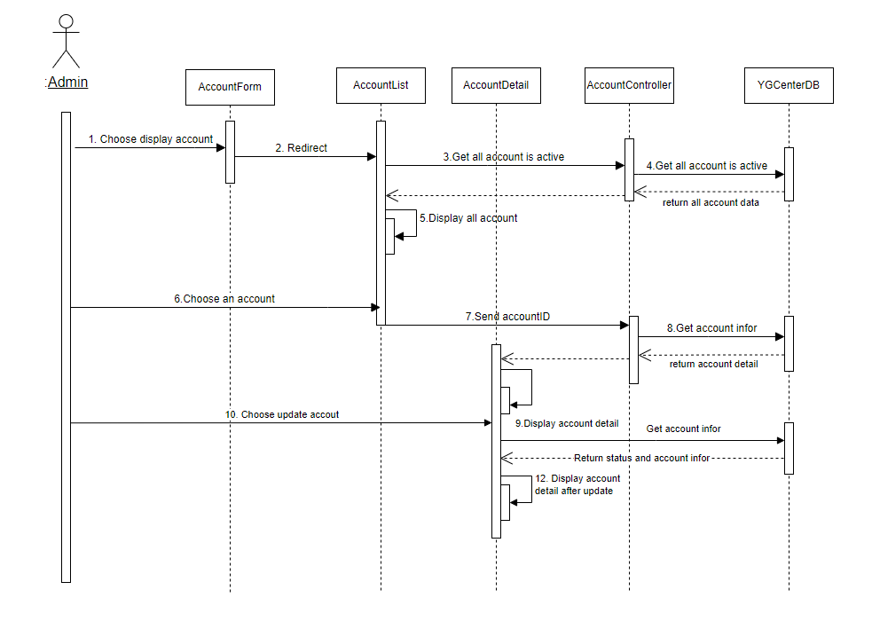

### d. Database Queries

– select * from tblAccount where account_id=?

– select * from tblAccount

– update tblAccount set account_is_active =? where account_id=?

– select account_email from tblAccount where account_email =?

– select * from tblAccount where account_name Like ?

– SELECT DATEPART(MONTH, create_date) AS [Month], COUNT(account_id) AS [total] FROM tblAccount where role_id=? and YEAR(create_date)=? GROUP BY DATEPART(MONTH, [create_date]) ORDER BY [Month]

– select YEAR(create_date) as year from tblAccount where role_id=? group by YEAR(create_date) order by YEAR(create_date) desc

– select * from tblAccount order by account_id desc OFFSET ? ROWS FETCH NEXT? ROWS ONLY

– select count(*) as num from tblAccount

## 4. View Timetable

### a. Class Diagram

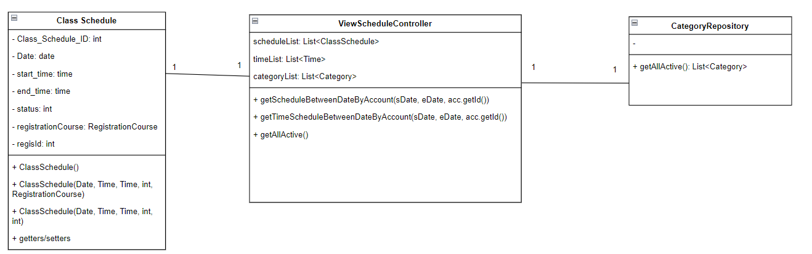

### b. Class Specifications

#### Class Schedule Model

| **No** | **Method** | **Description** |
| --- | --- | --- |
| 01 | Getter/setter | Get value and set value for attributes |
| 02 | Constructor | Generate Class Schedule object |

#### 

#### ClassScheduleRepository Class

| **No** | **Method** | **Description** |
| --- | --- | --- |
| 01 | getScheduleBetweenDateByAccount(Date startDate,Date endDate, int accountId) | Function used to query data, get list date in the week by account ID from the database |
| 02 | getTimeScheduleBetweenDateByAccount(Date startDate, Date endDate, int accountId) | Function used to query data, get list time in date by account ID from the database |

#### 

#### CategoryRepository Class

| **No** | **Method** | **Description** |
| --- | --- | --- |
| 01 | getAllActive() | Function used to query data, get category list has category_is_active = 1 from database |

#### 

#### ViewScheduleController Class

| **No** | **Method** | **Description** |
| --- | --- | --- |
| 01 | doget() | Function to get current week in timetable |
| 02 | doPost() | Function to formatting date |
| 03 | -loadScheduleOfDate(LocalDate date, HttpServletRequest request) | Function to load data for a date in a week |

#### 

### c. Sequence Diagram(s)

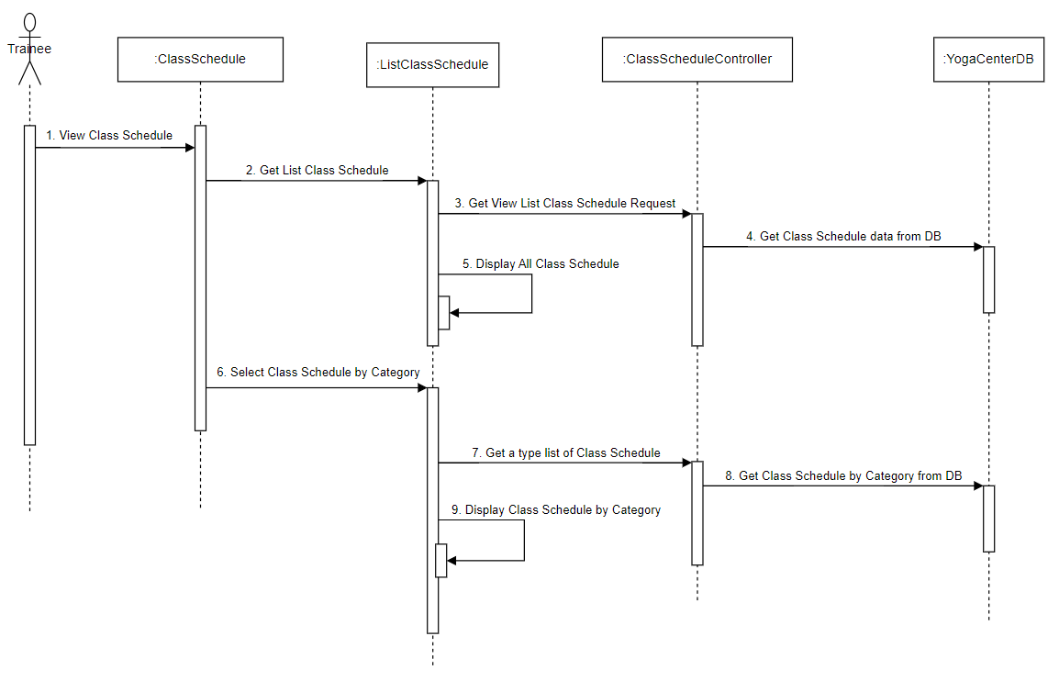***d. Database Queries***

***SELECT*** *cs.slot_start_time*

***FROM***

*(****SELECT*** *slot_start_time, registration_id*

***FROM*** *tblClassSchedule*

***WHERE*** *class_date* ***BETWEEN***  *[slot_start_time]* ***AND*** *[slot_end_time]) cs*

***JOIN***

*(****SELECT*** *registration_id*

***FROM*** *tblRegistrationCourse*

***WHERE*** *account_id=[accountId] ) rc*

***ON*** *cs.registration_id=rc.registration_id*

***GROUP BY*** *slot_start_time*

***ORDER BY*** *slot_start_time* ***ASC***

***SELECT*** *\**

***FROM***

*(****SELECT*** *\**

***FROM*** *tblClassSchedule*

***WHERE*** *class_date BETWEEN [slot_start_time] AND [slot_end_time]) cs*

***JOIN***

*(****SELECT*** *registration_id*

***FROM*** *tblRegistrationCourse*

***WHERE*** *account_id=[accountId] AND registration_status=1 ) rc*

***ON*** *cs.registration_id=rc.registration_id*

***ORDER BY*** *class_date* ***ASC*** *, slot_start_time* ***ASC***

***SELECT*** *\**

***FROM*** *tblCategory*

***WHERE*** *category_is_active=1";*

## 5. Booking course

### a. Class Diagram

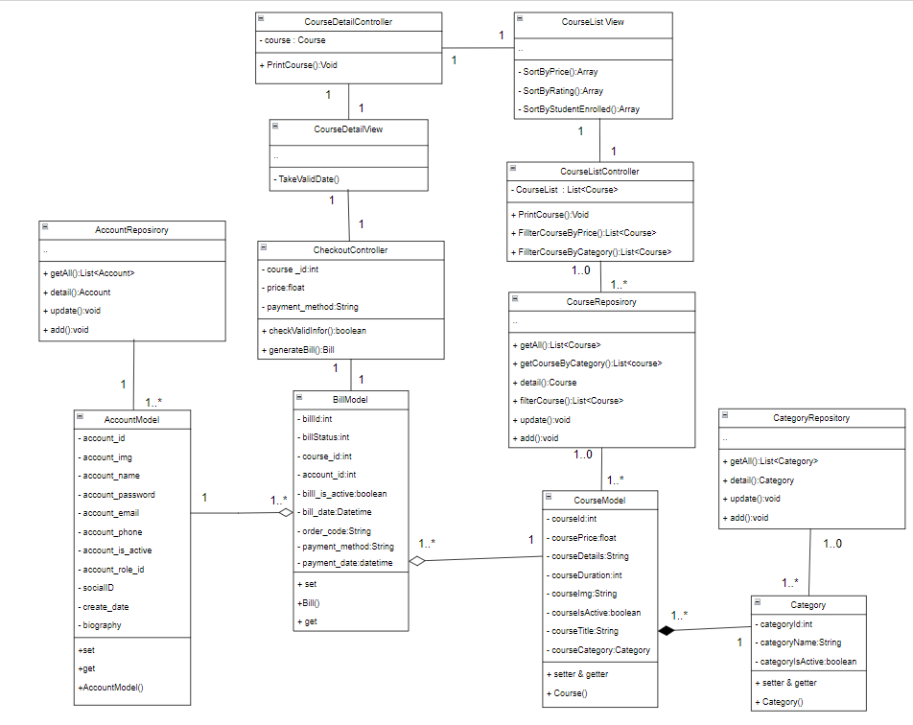

### b. Class Specifications

### AccountRepository Class

| **No** | **Method** | **Description** |
| --- | --- | --- |
| 01 | getAll() | Get all accounts in the database where the active field is true, there is no input parameter, the output is the account list |
| 02 | detail() | Get an account in the database where account_id is equal to the input parameter, the output is an account |
| 03 | update() | Update an account in the database where account_id is equal to the input parameter, with no output |
| 04 | add() | Add an account into the database, email is not duplicate, input is an account, no output |

#### 

***AccountModel Class***

| **No** | **Method** | **Description** |
| --- | --- | --- |
| 01 | setter() | Set data for attributes in class |
| 02 | getter() | Get data value from attribute in class |
| 03 | AccountModel() | Constructor for class |

***CheckoutController Class***

| **No** | **Method** | **Description** |
| --- | --- | --- |
| 01 | checkValidInfor() | Method check payment information from user |
| 02 | generateBill() | Method to generate bill base on payment information, output is bill  , input are course_id, account_id, price, Payment_method, Payment_date, order_code, bill_status |

***CategoryRepository Class***

| **No** | **Method** | **Description** |
| --- | --- | --- |
| 01 | getAll() | Get all category in database where active is true, output is category list, no input |
| 02 | detail() | Get a category in database where category_id equal with input parameter, output is a category |
| 03 | update() | Update a category in database where category_id equal with input category object, no output |
| 04 | add() | Add new category into database , input is a category object, no output |

***Category Class***

| **No** | **Method** | **Description** |
| --- | --- | --- |
| 01 | setter() | Set data for attributes in class |
| 02 | getter() | Get data value from attribute in class |
| 03 | Category() | Constructor for class |

***CourseModel Class***

| **No** | **Method** | **Description** |
| --- | --- | --- |
| 01 | setter() | Set data for attributes in class |
| 02 | getter() | Get data value from attribute in class |
| 03 | Course() | Constructor for class |

***CourseRepository Class***

| **No** | **Method** | **Description** |
| --- | --- | --- |
| 01 | getAll() | Get all course in database where active is true, output is course list, no input |
| 02 | getCourseByCategory() | Get all course in the database where category_id equal with input parameter, output is course list |
| 03 | update() | Update a course in database where course_id equal with input course object, no output |
| 04 | add() | Add new course into database , input is a course object, no output |
| 05 | filterCourse() | Get all course in database where course is satisfy: price in range min max, category_id equal with input parameter, input include min , max price and category_id, output is a course list |
| 06 | detail() | Get a course in database where course_id equal with input parameter, output is an account |

***CourseListController Class***

| **No** | **Method** | **Description** |
| --- | --- | --- |
| 01 | PrintCourse() | Give course list an print at CourseListview page |
| 02 | FilterCourseByPrice() | Take data filter by using CourseRepositoy, input is price min, price max, output is course list |
| 03 | FilterCourseByCategory() | Take data filter by using courseRepository, input is category, output is course list |

***CourseListView Class***

| **No** | **Method** | **Description** |
| --- | --- | --- |
| 01 | SortByPrice() | Sort array course follow price by using build in method sort(), input is array course, output is array sorted course |
| 02 | SortByRating() | Sort array course follow rating star by using build in method sort(), input is array course, output is array sorted course |
| 03 | SortByStudentEnrolled() | Sort array course follow rating star by using build in method sort(), input is array course, output is array sorted course |

***CourseDetailController Class***

| **No** | **Method** | **Description** |
| --- | --- | --- |
| 01 | PrintCourse() | Print course info at courseDetailView |

***CourseDetailView Class***

| **No** | **Method** | **Description** |
| --- | --- | --- |
| 01 | TakeValidDate() | check valid date from user when booking course, no in put, output is date |

### c. Sequence Diagram(s)

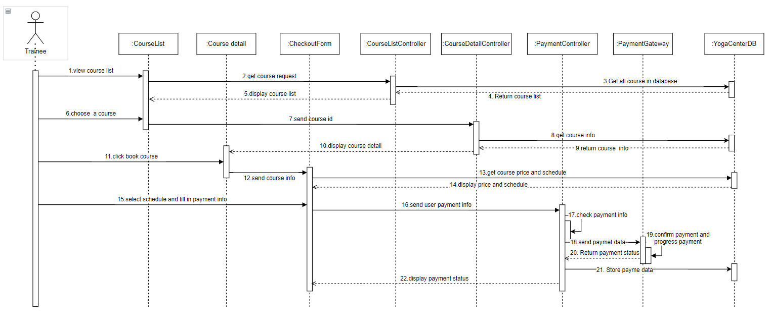

### d. Database Queries

*SELECT * FROM tblCategory WHERE category_is_active = 1;*

*SELECT * FROM tblCategory WHERE category_id = <category_id>;*

*UPDATE tblCategory SET category_name = <category_name>, category_is_active = <category_is_active> WHERE category_id = <category_id>;*

*INSERT INTO tblCategory (category_name, category_is_active) VALUES (<category_name>, <category_is_active>);*

*UPDATE tblCourse SET course_title = <course_title>, course_is_active = <course_is_active>, course_detail = <course_detail>, course_duration = <course_duration>, course_img = <course_img>, course_price = <course_price>, category_id = <category_id>, account_id = <account_id> WHERE course_id = <course_id>;*

*SELECT * FROM tblCourse WHERE course_id = <course_id>;*

*SELECT * FROM tblCourse WHERE course_is_active = 1 AND category_id = <category_id>;*

*SELECT * FROM tblCourse WHERE course_is_active = 1;*

*INSERT INTO tblBill (course_id, account_id, bill_status, bill_is_active, bill_value, bill_discount, bill_date, order_code, payment_method) VALUES (<course_id>, <account_id>, <bill_status>, <bill_is_active>, <bill_value>, <bill_discount>, <bill_date>, <order_code>, <payment_method>)*

## 6. Bill Analysis

### a. Class Diagram

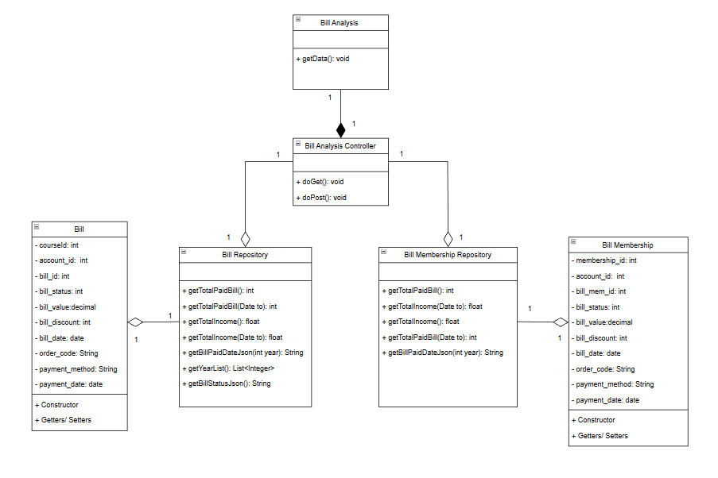

### b. Class Specifications

#### Bill Class

| **No** | **Method** | **Description** |
| --- | --- | --- |
| 01 | Getter | Get value in attributes |
| 02 | Setter | Set value for attributes |
| 03 | Constructor | Generate Bill object |

#### 

#### Bill Membership Class

| **No** | **Method** | **Description** |
| --- | --- | --- |
| 01 | Getter | Get value in attributes |
| 02 | Setter | Set value for attributes |
| 03 | Constructor | Generate Bill Mebership object |

#### Bill Repository

| **No** | **Method** | **Description** |
| --- | --- | --- |
| 01 | getTotalPaidBill() | Get numbers of bills that have the status “0” |
| 02 | getTotalPaidBill(Date to) | Get numbers of bills that have the status “0” and have payment_date <= “to” |
| 03 | getTotalIncome() | Get the total income of all bills |
| 04 | getTotalIncome(Date to) | Get the total income of all bills that have payment_date <= “to” |
| 05 | getBillPaidDateJson(int year) | Get the total number of bills for each month |
| 06 | getYearList() | Get list year of the payment_date |
| 07 | getBillStatusJson() | Get the total number of bills for each status |

#### Bill Membership Repository

| **No** | **Method** | **Description** |
| --- | --- | --- |
| 01 | getTotalPaidBill() | Get numbers of bills that have the status “0” |
| 02 | getTotalPaidBill(Date to) | Get numbers of bills that have the status “0” and have payment_date <= “to” |
| 03 | getTotalIncome() | Get the total income of all bills |
| 04 | getTotalIncome(Date to) | Get the total income of all bills that have payment_date <= “to” |
| 05 | getBillPaidDateJson(int year) | Get the total number of bills for each month |

#### Bill Analysis Controller

| **No** | **Method** | **Description** |
| --- | --- | --- |
| 01 | doGet() | Get data from Yoga Center Database, generate and set attributes into request than forward to ViewBillAnalysis.jsp |
| 02 | doPost() | Input is select tag in ViewBillAnalysis.jsp. Get input then generate chart follow year. |

### c. Sequence Diagram(s)

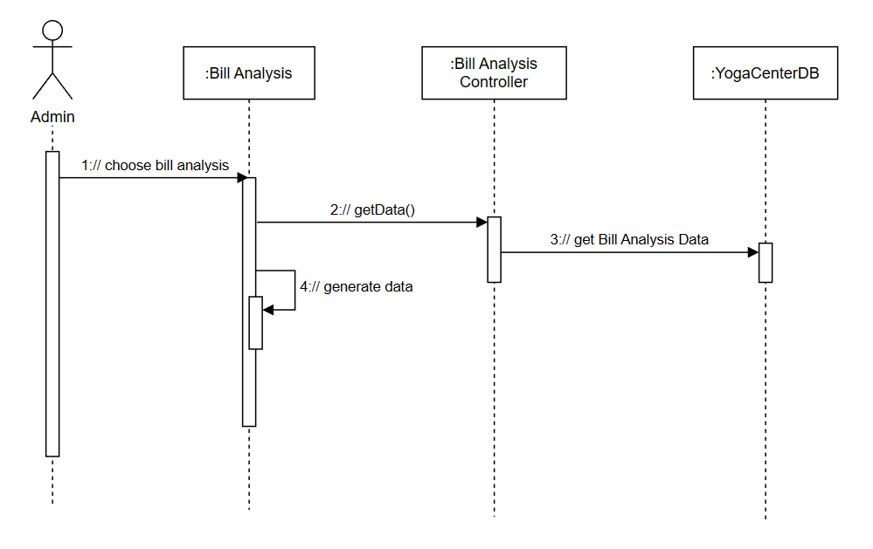

### d. Database Queries

SELECT count(*) as num FROM tblBill WHERE bill_status = 0

SELECT count(*) as num FROM tblBill WHERE bill_status = 0 and payment_date<=?

SELECT SUM(bill_value) as income FROM tblBill WHERE bill_status = 0

SELECT SUM(bill_value) as income FROM tblBill WHERE bill_status = 0 and payment_date<=?

SELECT DATEPART(MONTH, payment_date) AS [Month], COUNT(bill_id) AS [total] FROM tblBill WHERE bill_status=0 and YEAR(payment_date)=? GROUP BY DATEPART(MONTH, [payment_date]) ORDER BY [Month]

SELECT YEAR(payment_date) as year FROM tblBill WHERE bill_status = 0 GROUP BY YEAR(payment_date) ORDER BY YEAR(payment_date) desc

SELECT bill_status AS status, COUNT(*) AS total_count FROM ( SELECT bill_status FROM tblBill UNION ALL SELECT bill_status FROM tblBillMembership ) AS combined_tables GROUP BY bill_status

SELECT count(*) as num FROM tblBillMembership WHERE bill_status = 0

SELECT count(*) as num FROM tblBillMembership WHERE bill_status = 0 and payment_date<=?

SELECT SUM(bill_value) as income FROM tblBillMembership WHERE bill_status = 0

SELECT SUM(bill_value) as income FROM tblBillMembership WHERE bill_status = 0 and payment_date<=?

SELECT DATEPART(MONTH, payment_date) AS [Month], COUNT(bill_mem_id) AS [total] FROM tblBillMembership where bill_status=0 and YEAR(payment_date)=? GROUP BY DATEPART(MONTH, [payment_date]) ORDER BY [Month]

## 7. Rating course

### a. Class Diagram

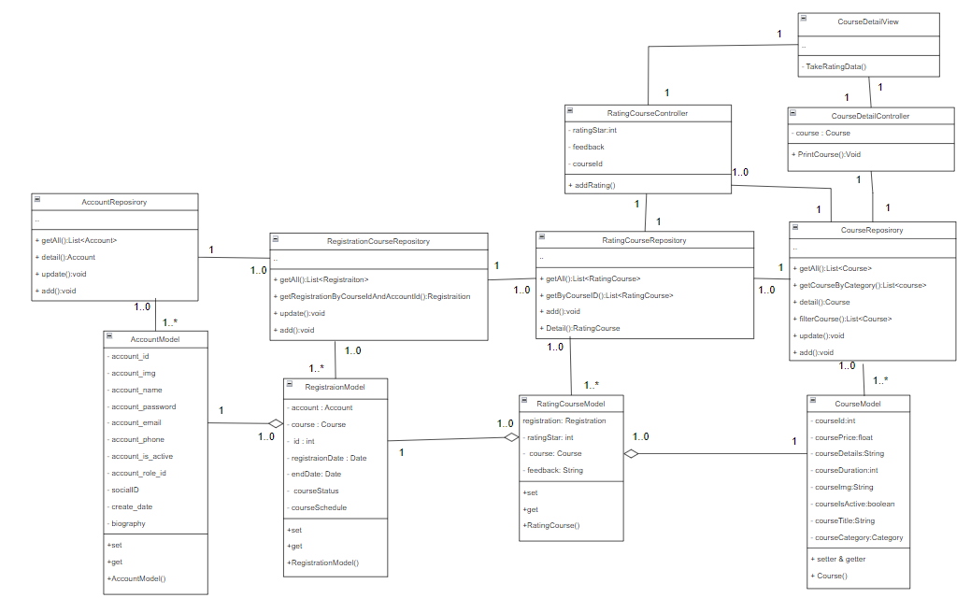

### b. Class Specifications

***CourseModel Class***

| **No** | **Method** | **Description** |
| --- | --- | --- |
| 01 | setter() | Set data for attributes in class |
| 02 | getter() | Get data value from attribute in class |
| 03 | Course() | Constructor for class |

***CourseRepository Class***

| **No** | **Method** | **Description** |
| --- | --- | --- |
| 01 | getAll() | Get all course in database where active is true, output is course list, no input |
| 02 | getCourseByCategory() | Get all course in database where category_id equal with input parameter, output is course list |
| 03 | update() | Update a course in database where course_id equal with input course object, no output |
| 04 | add() | Add new course into database , input is a course object, no output |
| 05 | filterCourse() | Get all course in database where course is satisfy: price in range min max, category_id equal with input parameter, input include min , max price and category_id, output is a course list |
| 06 | detail() | Get a course in database where course_id equal with input parameter, output is an account |

### AccountRepository Class

| **No** | **Method** | **Description** |
| --- | --- | --- |
| 01 | getAll() | Get all accounts in the database where the active field is true, there is no input parameter, the output is the account list |
| 02 | detail() | Get an account in the database where account_id is equal to the input parameter, the output is an account |
| 03 | update() | Update an account in the database where account_id is equal to the input parameter, with no output |
| 04 | add() | Add an account into the database, email is not duplicate, input is an account, no output |

#### 

***AccountModel Class***

| **No** | **Method** | **Description** |
| --- | --- | --- |
| 01 | setter() | Set data for attributes in class |
| 02 | getter() | Get data value from attribute in class |
| 03 | AccountModel() | Constructor for class |

***RatingCourseModel Class***

| **No** | **Method** | **Description** |
| --- | --- | --- |
| 01 | setter() | Set data for attributes in class |
| 02 | getter() | Get data value from attribute in class |
| 03 | RatingCourseModel() | Constructor for class |

***RegistrationCourseRepository Class***

| **No** | **Method** | **Description** |
| --- | --- | --- |
| 01 | setter() | Set data for attributes in class |
| 02 | getter() | Get data value from attribute in class |

***RatingCourseRepository Class***

| **No** | **Method** | **Description** |
| --- | --- | --- |
| 01 | getAll() | Get all rating course in database, no input , output is a list rating course |
| 02 | getByCourseId() | Get all rating course in database where course id equal with course id input parameter, output is a list rating course |
| 03 | Add() | Add new a rating course to database where each rating have different registration course id different, input is a rating course object data, no output |
| 04 | Detail() | Get an rating course in database where course_id and registration id equal with input parameter, output is a rating course |

***RatingCourseController Class***

| **No** | **Method** | **Description** |
| --- | --- | --- |
| 01 | addRating() | Method take info of from request parameter and inster to database by using RatingCourseRepository |

***CourseDetailController Class***

| **No** | **Method** | **Description** |
| --- | --- | --- |
| 01 | PrintCourse() | Print course info at courseDetailView |

***CourseDetailView Class***

| **No** | **Method** | **Description** |
| --- | --- | --- |
| 01 | TakeRatingData() | create ui, take data and send rating data to CourseRatingController when user click button “post”, no input and output. |

### c. Sequence Diagram(s)

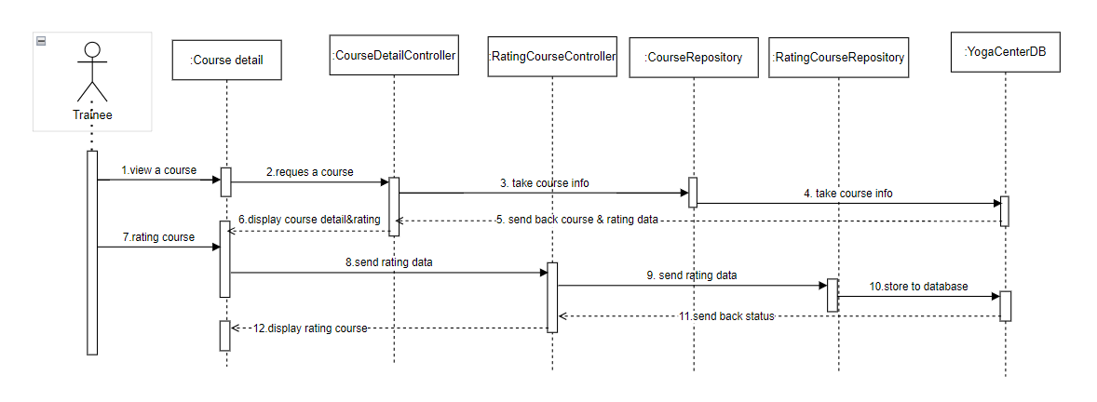

### d. Database Queries

*SELECT * FROM tblRatingCourse*

*SELECT * FROM tblRatingCourse WHERE course_id = <course_id>*

*SELECT * FROM tblRatingCourse WHERE registration_id = <registration_id>*

*INSERT INTO tblRatingCourse (registration_id, feedback, rating_star, course_id) VALUES (<registration_id>, <feedback>, <rating_star>, <course_id>)*

*UPDATE tblCourse SET course_title = <course_title>, course_is_active = <course_is_active>, course_detail = <course_detail>, course_duration = <course_duration>, course_img = <course_img>, course_price = <course_price>, category_id = <category_id>, account_id = <account_id> WHERE course_id = <course_id>;*

*SELECT * FROM tblCourse WHERE course_id = <course_id>;*

*SELECT * FROM tblCourse WHERE course_is_active = 1 AND category_id = <category_id>;*

*SELECT * FROM tblCourse WHERE course_is_active = 1;*

## 8. Cashier ViewBill

### a. Class Diagram

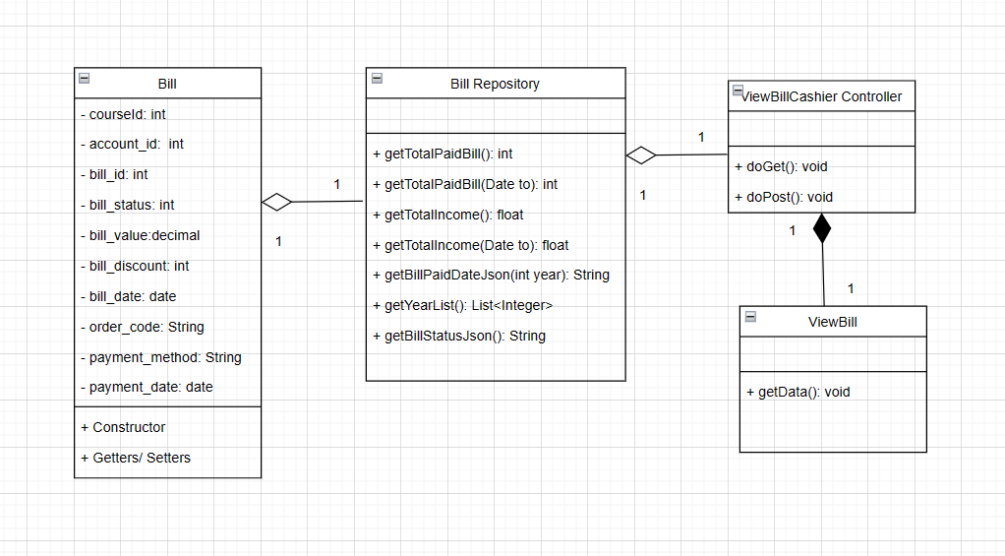

### b. Class Specifications

***BillModel Class***

| **No** | **Method** | **Description** |
| --- | --- | --- |
| 01 | setter() | Set data for attributes in class |
| 02 | getter() | Get data value from attribute in class |
| 03 | Bill() | Constructor for class |
| 04 | BillStatus{COMPLETED,CANCELLED,PENDING} | Three statuses of Bill and it will change when the cashier updates the status |
| 05 | BillStatus getEnumIndex(int i) | Get each element in the array |

***BillRepository Class***

| **No** | **Method** | **Description** |
| --- | --- | --- |
| 01 | getAll() | Get all bill in database, no input, output is a list of bill |
| 02 | getCourseIdByOrdercode(String ordercode) | Get all bill where order_code = ? |
| 03 | getAllByAccountIdAndCourseID(String accountId, int courseId ) | Get all bill where account_id = ? AND course_id = ? |
| 04 | updateStatus(String ordercode, LocalDate date, int status) | Update bill_status and payment_date where order_code = ? |
| 05 | detail(int id) | Get all bill where bill_id = ? |

***ViewBillCashierController Class***

| **No** | **Method** | **Description** |
| --- | --- | --- |
| 01 | doGet() | Method get all bill by using BillRepository |

### c. Sequence Diagram(s)

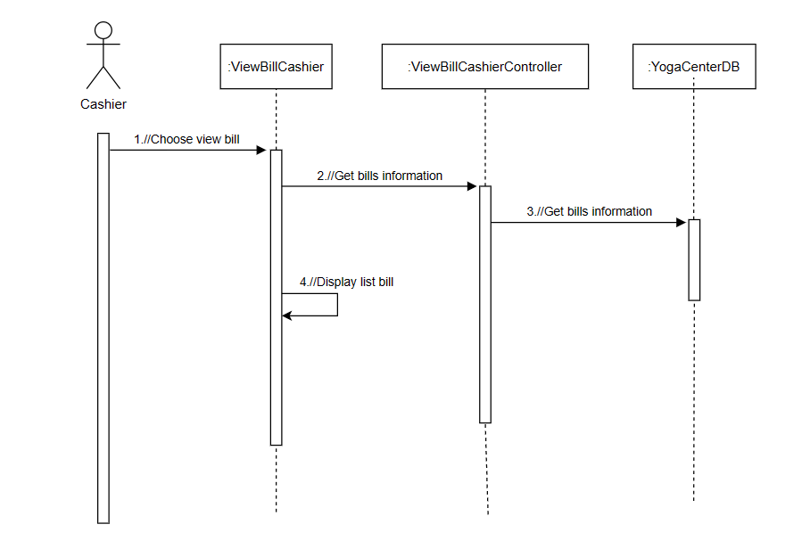

### d. Database Queries

select * from tblBill

## 9. Blog Analysis

### a. Class Diagram

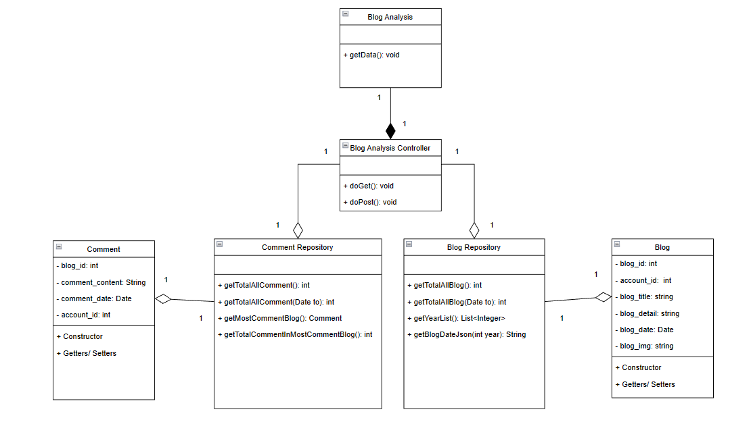

### b. Class Specifications

#### Blog Class

| **No** | **Method** | **Description** |
| --- | --- | --- |
| 01 | Getter | Get value in attributes |
| 02 | Setter | Set value for attributes |
| 03 | Constructor | Generate Blog object |

#### 

#### Comment Class

| **No** | **Method** | **Description** |
| --- | --- | --- |
| 01 | Getter | Get value in attributes |
| 02 | Setter | Set value for attributes |
| 03 | Constructor | Generate Comment object |

#### Blog Repository

| **No** | **Method** | **Description** |
| --- | --- | --- |
| 01 | getTotalAllBlog() | Get numbers of blog that have the status “0” |
| 02 | getTotalAllBlog(Date to) | Get numbers of blog that have the status “0” and have blog_date <= “to” |
| 03 | getBlogDateJson(int year) | Get the total number of blog for each month |
| 04 | getYearList() | Get list year of the blog_date |

#### Comment Repository

| **No** | **Method** | **Description** |
| --- | --- | --- |
| 01 | getTotalAllComment() | Get numbers of comment |
| 02 | getTotalAllComment(Date to) | Get numbers of comment that have comment_date <= “to” |
| 03 | getMostCommentBlog() | Get the blog that have most comments |
| 04 | getTotalCommentInMostCommentBlog() | Get the total comments in the blog that have most comments |

#### Blog Analysis Controller

| **No** | **Method** | **Description** |
| --- | --- | --- |
| 01 | doGet() | Get data from Yoga Center Database, generate and set attributes into request than forward to ViewBlogAnalysis.jsp |
| 02 | doPost() | Input is select tag in ViewBlogAnalysis.jsp. Get input then generate chart follow year. |

### c. Sequence Diagram(s)

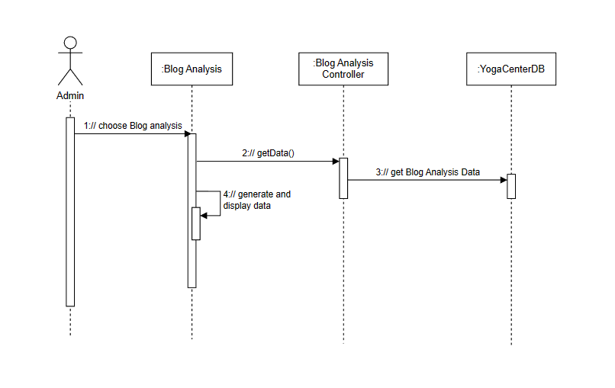

### d. Database Queries

SELECT count(*) as num FROM tblBlog

SELECT count(*) as num FROM tblBlog WHERE blog_date <= ?

SELECT DATEPART(MONTH, blog_date) AS [Month], COUNT(blog_id) AS [total] FROM tblBlog WHERE YEAR(blog_date)=? GROUP BY DATEPART(MONTH, [blog_date]) ORDER BY [Month]

SELECT YEAR(blog_date) as year FROM tblBlog GROUP BY YEAR(blog_date) order by YEAR(blog_date) DESC

SELECT count(*) as num from tblComment

SELECT count(*) as num from tblComment where comment_date <= ?

SELECT blog_id , COUNT(comment_content) as total FROM tblComment GROUP BY blog_id ORDER BY total DESC OFFSET 0 ROWS FETCH NEXT 1 ROWS ONLY

SELECT blog_id , COUNT(comment_content) as total FROM tblComment GROUP BY blog_id ORDER BY total DESC OFFSET 0 ROWS FETCH NEXT 1 ROWS ONLY

## 10. Cashier UpdateBill

### a. Class Diagram

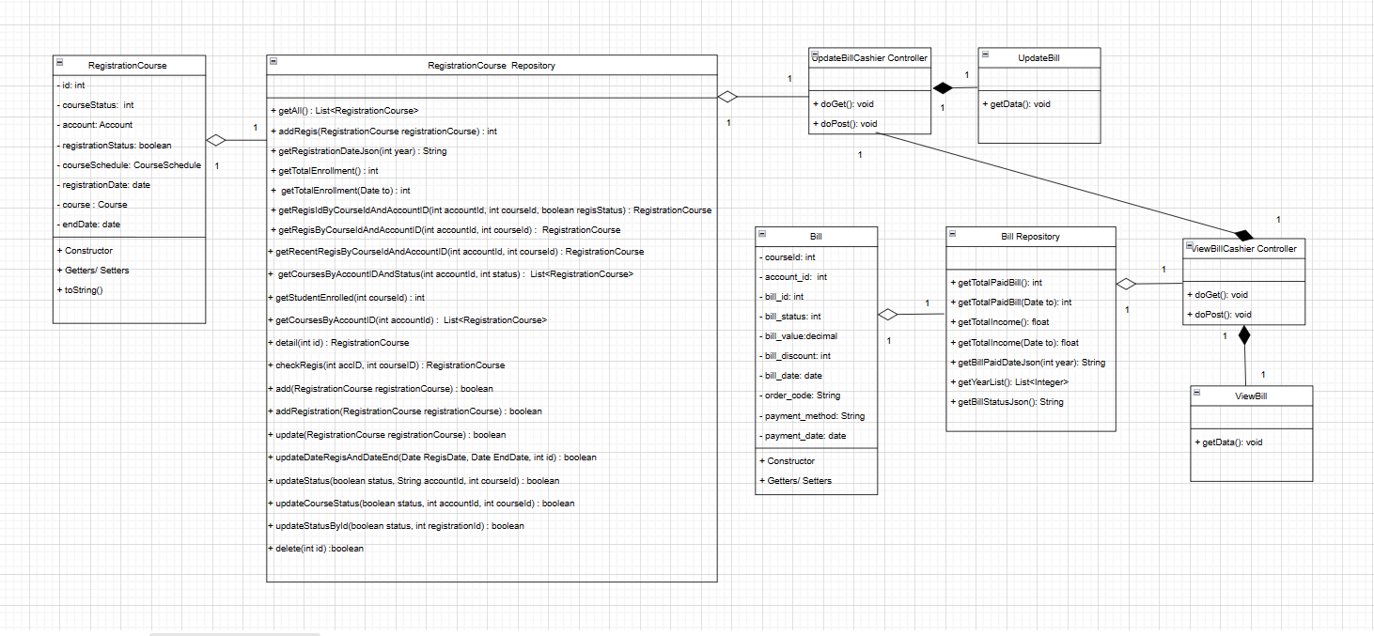

### b. Class Specifications

***BillModel Class***

| **No** | **Method** | **Description** |
| --- | --- | --- |
| 01 | setter() | Set data for attributes in class |
| 02 | getter() | Get data value from attribute in class |
| 03 | Bill() | Constructor for class |
| 04 | BillStatus{COMPLETED,CANCELLED,PENDING} | Three statuses of Bill and it will change when the cashier updates the status |
| 05 | BillStatus getEnumIndex(int i) | Get each element in the array |

***BillRepository Class***

| **No** | **Method** | **Description** |
| --- | --- | --- |
| 01 | getAll() | Get all bill in database, no input, output is a list of bill |
| 02 | getCourseIdByOrdercode(String ordercode) | Get all bill where order_code = ? |
| 03 | getAllByAccountIdAndCourseID(String accountId, int courseId ) | Get all bill where account_id = ? AND course_id = ? |
| 04 | updateStatus(String ordercode, LocalDate date, int status) | Update bill_status and payment_date where order_code = ? |
| 05 | detail(int id) | Get all bill where bill_id = ? |

***RegistrationCourseRepository Class***

| **No** | **Method** | **Description** |
| --- | --- | --- |
| 01 | getRecentRegisByCourseIdAndAccountID(int accountId, int courseId) | Get all registration course where account_id = ? AND course_id = ? , and order by registration_id desc |
| 02 | updateStatusById(boolean status, int registrationId) | Update registration_status WHERE registration_id = ? |

***UpdateBillCashierController Class***

| **No** | **Method** | **Description** |
| --- | --- | --- |
| 01 | doGet() | Get information details to update form |
| 02 | doPost() | Update bill_status and payment_date and update registration_status by using BillRepository and RegistrationCourseRepository |

### c. Sequence Diagram(s)

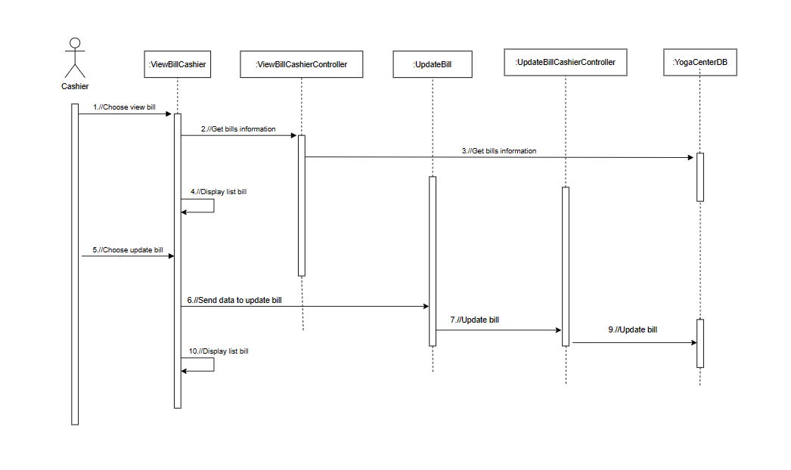

### d. Database Queries

select * from tblBill where bill_id=?

UPDATE tblBill SET bill_status = ? , payment_date =? WHERE order_code = ?

select * from tblBill where order_code=?

select * from tblRegistrationCourse WHERE account_id = ? AND course_id = ? order by registration_id desc

UPDATE tblRegistrationCourse SET registration_status = ? WHERE registration_id = ?

## 11. Update User Profile

### a. Class Diagram

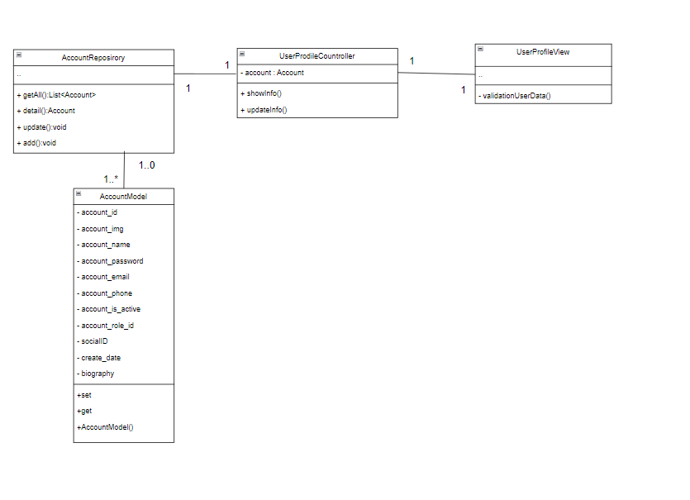

### b. Class Specifications

### AccountRepository Class

| **No** | **Method** | **Description** |
| --- | --- | --- |
| 01 | getAll() | Get all accounts in the database where the active field is true, there is no input parameter, and the output is the account list |
| 02 | detail() | Get an account in the database where account_id is equal to the input parameter, the output is an account |
| 03 | update() | Update an account in the database where account_id is equal to the input parameter, with no output |
| 04 | add() | Add an account into the database, email is not duplicate, input is an account, no output |

#### 

***AccountModel Class***

| **No** | **Method** | **Description** |
| --- | --- | --- |
| 01 | setter() | Set data for attributes in class |
| 02 | getter() | Get data value from attribute in class |
| 03 | AccountModel() | Constructor for class |

***UserProfileController Class***

| **No** | **Method** | **Description** |
| --- | --- | --- |
| 01 | showInfo() | Take user data from database and show on UserProfileView, input is account id, no output |
| 02 | updateInfo() | Take info from UserProfileView and update to database, input is an account object, output is boolean |

***UserProfileView Class***

| **No** | **Method** | **Description** |
| --- | --- | --- |
| 01 | validationData() | Method get user data input and check validation, input is name, phone, email, and password, output is boolean |

### c. Sequence Diagram(s)

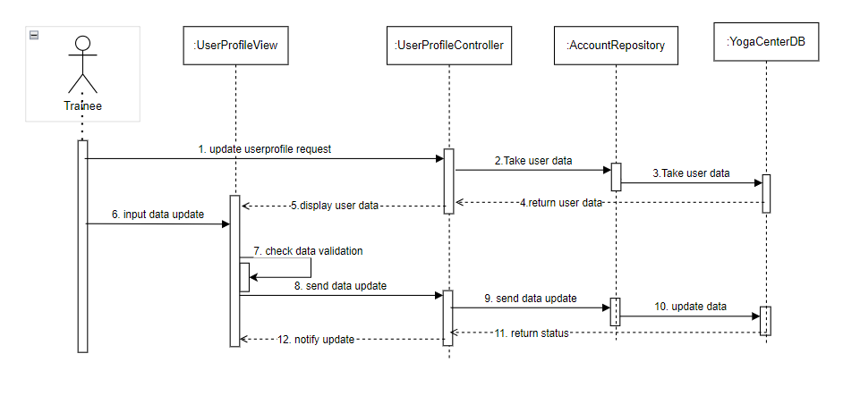

### d. Database Queries

*INSERT INTO tblAccount ( account_img, account_name, account_password, account_email, account_phone, account_is_active, role_id, social_id, biography) VALUES (<account_img>, <account_name>, <account_password>, <account_email>, <account_phone>, <account_is_active>, <role_id>, <social_id>, <biography>)*

*UPDATE tblAccount SET account_name=<account_name> , account_password= <account_password> ,account_img= <account_img> , account_email= <account_email> , account_phone= <account_phone> , account_is_active= <account_is_active>, biography= <biography> where account_id= <where account_id>*

*SELECT * FROM tblAccount where account_id= <account_id>*

*SELECT * FROM tblAccount*

## 12. View Timetable List

### a. Class Diagram

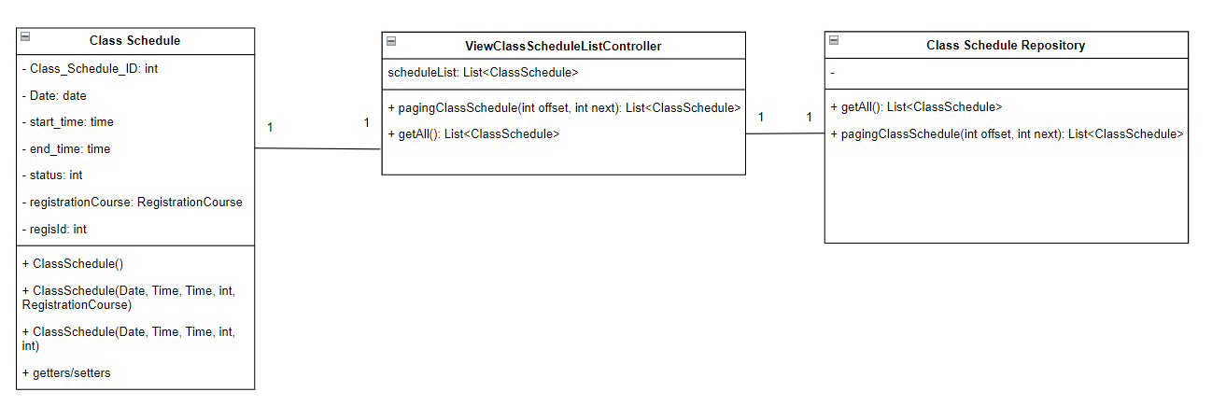

### b. Class Specifications

***Class Schedule Model***

| No | Method | Description |
| --- | --- | --- |
| 01 | Getter/setter | Get value and set value for attributes |
| 02 | Constructor | Generate Class Schedule object |

**ClassScheduleRepository Class**

| No | Method | Description |
| --- | --- | --- |
| 01 | pagingClassSchedule(int offset, int next) | Function used to get a list of data in the database and use OFFSET to paginate this data list |

**ViewClassScheduleListController Class**

| No | Method | Description |
| --- | --- | --- |
| 01 | doget() | Function to getting list data then request dispatch into JSP page |

### c. Sequence Diagram(s)

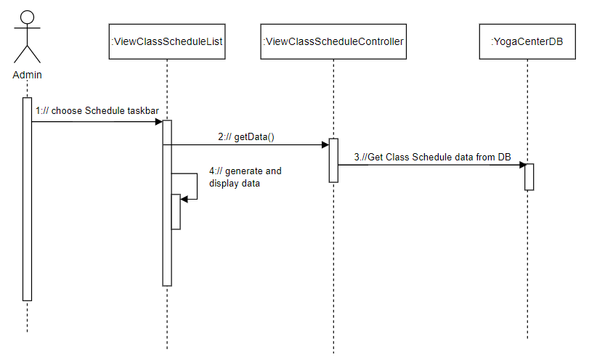

### d. Database Queries

SELECT *

FROM tblClassSchedule

ORDER BY class_schedule_id

OFFSET ? ROWS FETCH NEXT ? ROWS ONLY

## 13. Buy membership

### a. Class Diagram

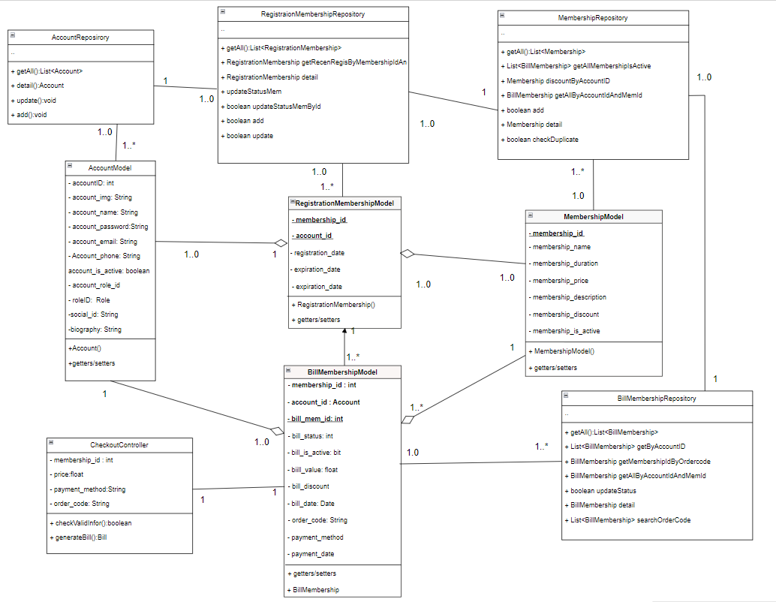

### b. Class Specifications

#### Membership Model Class

| **No** | **Method** | **Description** |
| --- | --- | --- |
| 01 | Getter() | Get value in attributes |
| 02 | Setter() | Set value for attributes |
| 03 | Membership() | Generate Course object |

#### Account Model Class

| **No** | **Method** | **Description** |
| --- | --- | --- |
| 01 | Account() | Constructor for class. |
| 02 | setter() | Method to set the date in class. |
| 03 | getter() | Method to get the date from class. |

#### BillMembership Class

| **No** | **Method** | **Description** |
| --- | --- | --- |
| 01 | Getter() | Get value in attributes |
| 02 | Setter() | Set value for attributes |
| 03 | BillMembership () | Generate Membership object |

#### RegistrationMembership Model Class

| **No** | **Method** | **Description** |
| --- | --- | --- |
| 01 | DisplayBill() | Use jsp, jstl, css to generate view for checkout |

#### PaymentGateway Class

| **No** | **Method** | **Description** |
| --- | --- | --- |
| 01 | vnpay_payment(.) | Send information of the bill to payment gateway and get back attribute to store in database |

#### 

#### RegistrationMembership Repository Class

| **No** | **Method** | **Description** |
| --- | --- | --- |
| 01 | getAll():List<RegistrationMembership> | Get all registration membership in the database where active is true, the output is a registration membership list, no input |
| 02 | RegistrationMembershipDetail | Get all registration detail in the database by registration id =? |
| 03 | updateStatusMemById | Update status of registration_status |
| 04 | add | Add new registration membership |

#### 

#### Membership Repository Class

| **No** | **Method** | **Description** |
| --- | --- | --- |
| 01 | getAll():List<Membership> | Get all membership in the database where active is true, the output is a membership list, no input |
| 02 | getAllByAccountIdAndMemId | Get membership current of an account |
| 03 | add | Add new membership |
| 04 | detail | Get the detail of membership |

***Account Repository Class***

| **No** | **Method** | **Description** |
| --- | --- | --- |
| 01 | List<Account> getAll() | The function used to query data, get an account list from the database |
| 02 | updateAccount() | The function used to query data, edit data of account into the database |

### c. Sequence Diagram(s)

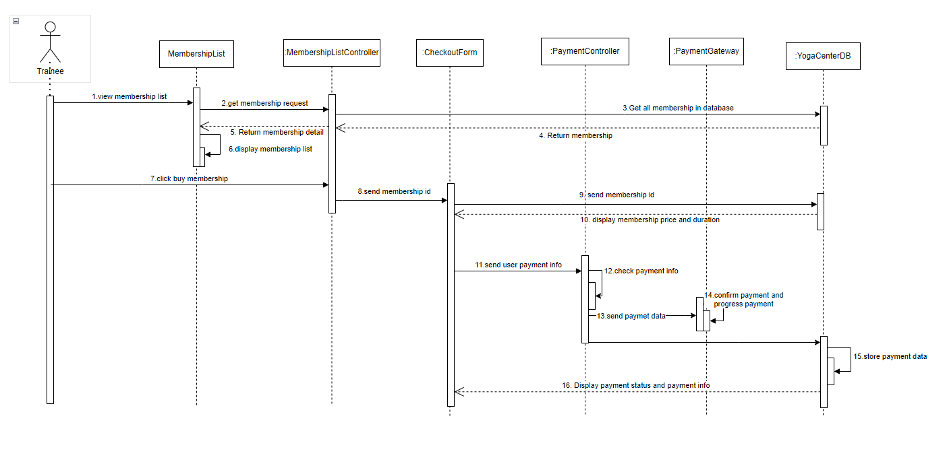

### d. Database Queries

AccountRepository  
select * from tblRegistrationMembership

select * from tblRegistrationMembership WHERE membership_id = ? AND account_id = ? order by membership_id desc

select * from tblRegistrationMembership where account_id=?

UPDATE tblRegistrationMembership SET registration_status = ?WHERE account_id = ? AND membership_id = ?

INSERT INTO tblRegistrationMembership (membership_id, account_id, registration_date, expriration_date, registration_status) VALUES (?, ?, ?, ?, ?)

**RegistrationMembership Repository Class**

select * from tblRegistrationMembership

INSERT INTO tblRegistrationMembership (membership_id, account_id, registration_date, expriration_date, registration_status) VALUES (?, ?, ?, ?, ?)

**Membership Repository Class**

select * from tblMembership

select * from tblMembership where membership_id=?

UPDATE tblMembership SET membership_name = ?, membership_duration = ?, membership_price = ?, membership_description = ?, membership_discours = ?, membership_is_active = ? WHERE membership_id = ?

## 14. View membership

### a. Class Diagram



### b. Class Specifications

#### Membership Model Class

| **No** | **Method** | **Description** |
| --- | --- | --- |
| 01 | Getter() | Get value in attributes |
| 02 | Setter() | Set value for attributes |
| 03 | Membership() | Generate Course object |

#### Account Model Class

| **No** | **Method** | **Description** |
| --- | --- | --- |
| 01 | Account() | Constructor for class. |
| 02 | setter() | Method to set the date in class. |
| 03 | getter() | Method to get the date from class. |

#### BillMembership Class

| **No** | **Method** | **Description** |
| --- | --- | --- |
| 01 | Getter() | Get value in attributes |
| 02 | Setter() | Set value for attributes |
| 03 | BillMembership () | Generate Membership object |

#### RegistrationMembership Model Class

| **No** | **Method** | **Description** |
| --- | --- | --- |
| 01 | DisplayBill() | Use jsp, jstl, css to generate view for checkout |

#### PaymentGateway Class

| **No** | **Method** | **Description** |
| --- | --- | --- |
| 01 | vnpay_payment(.) | Send information of the bill to payment gateway and get back attribute to store in database |

#### 

#### RegistrationMembership Repository Class

| **No** | **Method** | **Description** |
| --- | --- | --- |
| 01 | getAll():List<RegistrationMembership> | Get all registration membership in the database where active is true, the output is a registration membership list, no input |
| 02 | RegistrationMembershipDetail | Get all registration detail in the database by registration id =? |
| 03 | updateStatusMemById | Update status of registration_status |
| 04 | add | Add new registration membership |

#### 

#### Membership Repository Class

| **No** | **Method** | **Description** |
| --- | --- | --- |
| 01 | getAll():List<Membership> | Get all membership in the database where active is true, the output is a membership list, no input |
| 02 | getAllByAccountIdAndMemId | Get membership current of an account |
| 03 | add | Add new membership |
| 04 | detail | Get the detail of membership |

#### Bill Membership Repository Class

| **No** | **Method** | **Description** |
| --- | --- | --- |
| 01 | getAll():List<BillMembership> | Get all bill membership in the database where active is true, the output is a membership list, no input |
| 02 | getByAccountID | Get membership current of an account_id |
| 03 | getMembershipIdByOrdercode | Get membership current of an order_code |
| 04 | updateStatus | Update status of bill_membership_status where bill_membership_id=? |
| 05 | searchOrderCode | Search bill membership by order_code=? |

***Account Repository Class***

| **No** | **Method** | **Description** |
| --- | --- | --- |
| 01 | List<Account> getAll() | The function used to query data, get an account list from the database |
| 02 | updateAccount() | The function used to query data, edit data of account into the database |

### c. Sequence Diagram(s)



### d. Database Queries

**AccountRepository**  
select * from tblRegistrationMembership

select * from tblRegistrationMembership WHERE membership_id = ? AND account_id = ? order by membership_id desc

INSERT INTO tblRegistrationMembership (membership_id, account_id, registration_date, expriration_date, registration_status) VALUES (?, ?, ?, ?, ?)

**RegistrationMembership Repository Class**

select * from tblRegistrationMembership

select * from tblRegistrationMembership WHERE membership_id = ? AND account_id = ? order by membership_id desc

select * from tblRegistrationMembership where account_id=?

UPDATE tblRegistrationMembership SET registration_status =? WHERE account_id = ? AND membership_id = ?

INSERT INTO tblRegistrationMembership (membership_id, account_id, registration_date, expriration_date, registration_status) VALUES (?, ?, ?, ?, ?)

**Membership Repository Class**

select * from tblMembership

select * from tblMembership where membership_id=?

UPDATE tblMembership SET membership_name = ?, membership_duration = ?, membership_price = ?, membership_description = ?, membership_discours = ?, membership_is_active = ? WHERE membership_id = ?

select * from tblRegistrationMembership rm join tblMembership m on m.membership_id = rm.membership_id where rm.account_id = ?

## 15. View Bill

### a. Class Diagram

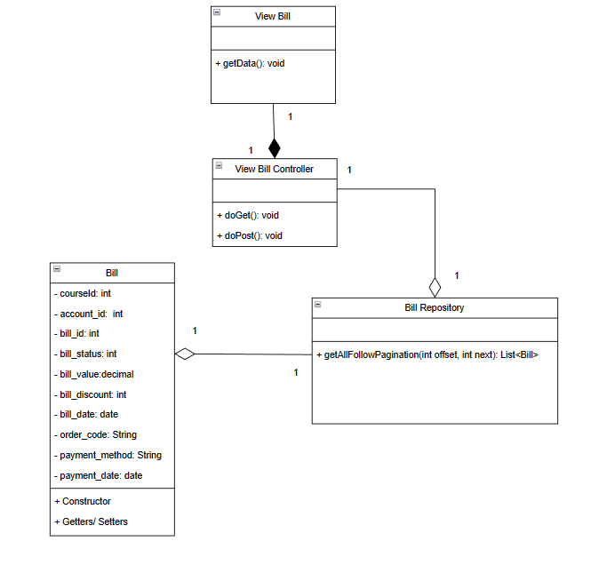

### b. Class Specifications

#### Bill Class

| **No** | **Method** | **Description** |
| --- | --- | --- |
| 01 | Getter | Get value in attributes |
| 02 | Setter | Set value for attributes |
| 03 | Constructor | Generate Bill object |

#### Bill Repository

| **No** | **Method** | **Description** |
| --- | --- | --- |
| 01 | getAllFollowPagination(int offset, int next): | Get all Bill with a range start with “offset” end with “next” |

#### Blog Analysis Controller

| **No** | **Method** | **Description** |
| --- | --- | --- |
| 01 | doGet() | Get data from Yoga Center Database, generate and set attributes into request than forward to ViewBillList.jsp |
| 02 | doPost() | Get data from Yoga Center Database, generate and set attributes into request than forward to ViewBillList.jsp |

### c. Sequence Diagram(s)

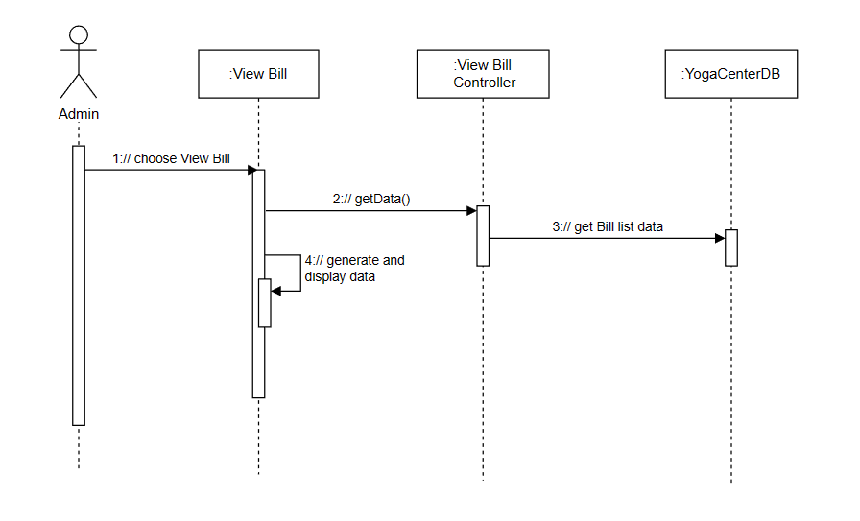

### d. Database Queries

SELECT * FROM tblBill ORDER BY bill_id DESC OFFSET ? ROWS FETCH NEXT ? ROWS ONLY

## 16. View Course Time List

### a. Class Diagram

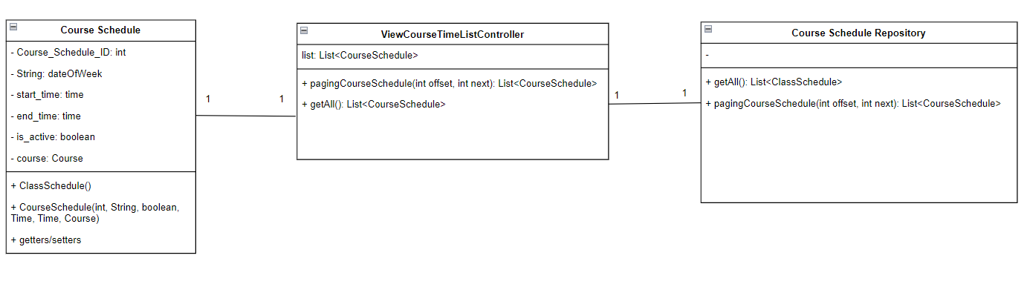

### 

### b. Class Specifications

***Course Schedule Model***

| No | Method | Description |
| --- | --- | --- |
| 01 | Getter/setter | Get value and set value for attributes |
| 02 | Constructor | Generate Course Schedule object |

**CourseScheduleRepository Class**

| No | Method | Description |
| --- | --- | --- |
| 01 | pagingCourseSchedule(int offset, int next) | Function used to get a list of data in the database and use OFFSET to paginate this data list |

**ViewCourseTimeListController Class**

| No | Method | Description |
| --- | --- | --- |
| 01 | doget() | Function to getting list data then request dispatch into JSP page |

### c. Sequence Diagram(s)

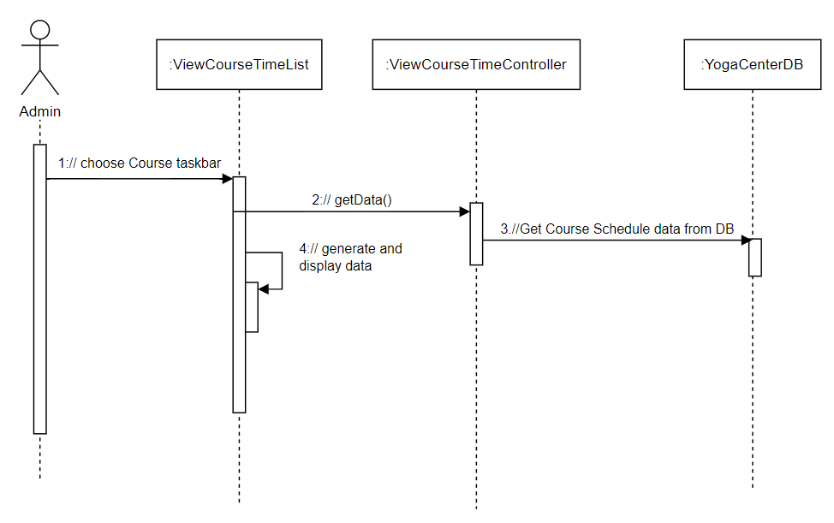

### 

### d. Database Queries

*SELECT \**

*FROM tblCourseSchedule*

*ORDER BY course_schedule_id*

*OFFSET? ROWS FETCH NEXT? ROWS ONLY*

## 17. Cancel Booking

### a. Class Diagram

### 

### ***b. Class Specifications***

### AccountRepository Class

| **No** | **Method** | **Description** |
| --- | --- | --- |
| 01 | getAll() | Get all accounts in the database where the active field is true, there is no input parameter, the output is the account list |
| 02 | detail() | Get an account in the database where account_id is equal to the input parameter, the output is an account |
| 03 | update() | Update an account in the database where account_id is equal to the input parameter, with no output |
| 04 | add() | Add an account into the database, email is not duplicate, input is an account, no output |

#### 

***AccountModel Class***

| **No** | **Method** | **Description** |
| --- | --- | --- |
| 01 | setter() | Set data for attributes in class |
| 02 | getter() | Get data value from attribute in class |
| 03 | AccountModel() | Constructor for class |

#### Bill Class

| **No** | **Method** | **Description** |
| --- | --- | --- |
| 01 | Getter | Get value in attributes |
| 02 | Setter | Set value for attributes |
| 03 | Constructor | Generate Bill object |

### BillRepository Class

| **No** | **Method** | **Description** |
| --- | --- | --- |
| 01 | getAll() | Get all bills in the database ,there is no input parameter, the output is the account list |
| 02 | detail() | Get an bill in the database where bill_id is equal to the input parameter, the output is an account |
| 03 | update() | Update an bill in the database where bill_id is equal to the input parameter, with no output |
| 04 | add() | Add an bill into the database, email is not duplicate, input is an bill, no output |
| 05 | getBillByAccount() | Get all bills in database where account_id bill equal with account_id input, output is a Bill list |

#### UserBookingProfileController Class

| **No** | **Method** | **Description** |
| --- | --- | --- |
| 01 | updateBillStatus() | Update bill status for a bill in database, input is status and bill id, output is boolean |
| 02 | getBillAccount() | Take all bill in database by using BillRepository , input is account id, output is a bill list |
| 03 | printBillList() | Print all bill into UserBookingProfileBill |

#### UserBookingProfileView Class

| **No** | **Method** | **Description** |
| --- | --- | --- |
| 01 | cancelBill() | Send action to controller and update status bill to cancelled, input is bill id, no output |
| 02 | viewBillDetail() | send request to UserBookingProfileController to get detail for a bill, input is bill id, output is detail of bill |

### 

### ***c. Sequence Diagram(s)***

### 

### 

### d. Database Queries

*SELECT * FROM tblBill*

*SELECT * FROM tblBill WHERE account_id=<account_id>*

*UPDATE tblBill SET bill_status = ? WHERE bill_id = <bill_id>*

*INSERT INTO tblBill (course_id, account_id, bill_status, bill_is_active, bill_value, bill_discount, bill_date, order_code, payment_method) VALUES (<course_id>, <account_id>, <bill_status>, <bill_is_active>, <bill_value>, <bill_discount>, <bill_date>, <order_code>, <payment_method>)*

*SELECT * FROM tblAccount WHERE account_id= <account_id>*

*SELECT * FROM tblAccount*

## 18. Cashier ViewBillMembership

### a. Class Diagram

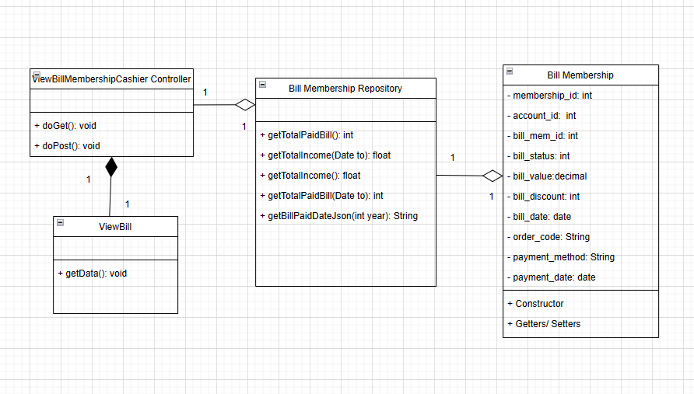

### b. Class Specifications

#### Bill Membership Class

| **No** | **Method** | **Description** |
| --- | --- | --- |
| 01 | Getter | Get value in attributes |
| 02 | Setter | Set value for attributes |
| 03 | Constructor | Generate Bill Mebership object |

#### Bill Membership Repository Class

| **No** | **Method** | **Description** |
| --- | --- | --- |
| 01 | getAll():List<BillMembership> | Get all bill membership in the database where active is true, the output is a membership list, no input |
| 02 | getByAccountID | Get membership current of an account_id |
| 03 | getMembershipIdByOrdercode | Get membership current of an order_code |
| 04 | updateStatus | Update status of bill_membership_status where bill_membership_id=? |
| 05 | searchOrderCode | Search bill membership by order_code=? |

#### ViewBillMembershipController Class

| **No** | **Method** | **Description** |
| --- | --- | --- |
| 01 | doGet() | Method get all bill membership by using BillMembershipRepository |

### c. Sequence Diagram(s)

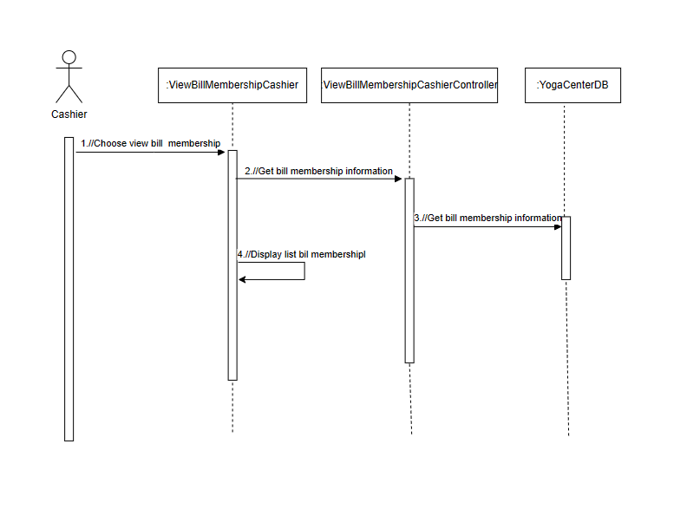

### d. Database Queries

select * from tblBillMembership

## 19. Cashier UpdateBillMembership

### a. Class Diagram

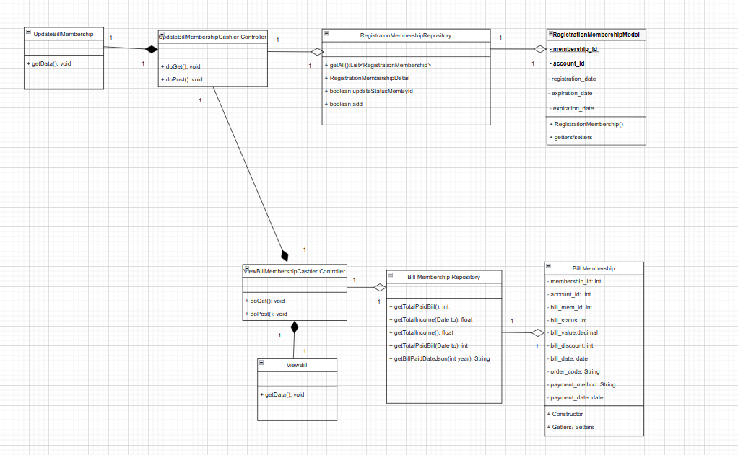

### b. Class Specifications

#### 

#### Bill Membership Class

| **No** | **Method** | **Description** |
| --- | --- | --- |
| 01 | Getter | Get value in attributes |
| 02 | Setter | Set value for attributes |
| 03 | Constructor | Generate Bill Membership object |

#### Bill Membership Repository Class

| **No** | **Method** | **Description** |
| --- | --- | --- |
| 01 | getAll():List<BillMembership> | Get all bill membership in the database where active is true, the output is a membership list, no input |
| 02 | getByAccountID | Get membership current of an account_id |
| 03 | getMembershipIdByOrdercode | Get membership current of an order_code |
| 04 | updateStatus | Update status of bill_membership_status where bill_membership_id=? |
| 05 | searchOrderCode | Search bill membership by order_code=? |

#### 

#### RegistrationMembership Repository Class

| **No** | **Method** | **Description** |
| --- | --- | --- |
| 01 | getAll():List<RegistrationMembership> | Get all registration memberships in the database where active is true, the output is a registration membership list, no input |
| 02 | RegistrationMembershipDetail | Get all registration detail in the database by registration id =? |
| 03 | updateStatusMemById | Update status of registration_status |
| 04 | add | Add new registration membership |

#### 

***UpdateBillMembershipCashierController Class***

| **No** | **Method** | **Description** |
| --- | --- | --- |
| 01 | doGet() | Get information details to update form |
| 02 | doPost() | Update bill_status and payment_date and update registration_status by using BillMembershipRepository and RegistrationMembershipRepository |

### c. Sequence Diagram(s)

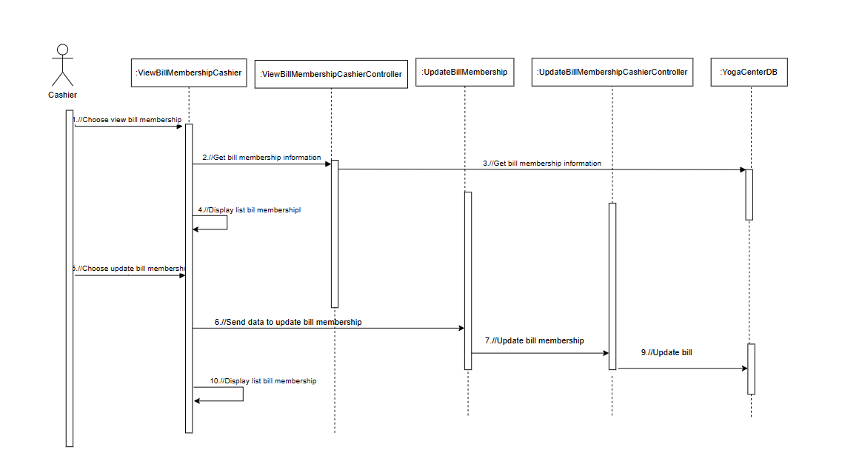

### d. Database Queries

select * from tblBillMembership where bill_mem_id=?

UPDATE tblBillMembership SET bill_status = ? , payment_date =? WHERE order_code = ?

select * from tblBillMembership where order_code=?

select * from tblRegistrationMembership WHERE membership_id = ? AND account_id = ? order by membership_id desc

UPDATE tblRegistrationMembership SET registration_status = ? WHERE membership_id = ?